Welcome to Worship!
February 11, 2024 Racial Justice Sunday

Greeting and Call to Worship
Prelude

*Responsive Call to Worship based on psalm Ps 50: 1-6
Leader: The mighty one, God the Lord, speaks and summons the
Earth from the rising of the sun to its setting.
People: Out of Zion, the perfection of beauty, God shines
forth.
Leader: Our God comes and does not keep silent; before him is a
devouring fire and a mighty tempest all around him.
People: He calls to the heavens above and to the earth, that he
may judge his people:
Leader: “Gather to me my faithful ones, who made a covenant
with me by sacrifice!”
People: The heavens declare his righteousness, for God
himself is judge. Selah

Opening Hymn: "For the Healing of the Nations" No. 621

*Unison Prayer of Invocation and Lord’s Prayer (debts)
Lord we think we got it covered--we are loving, just, and merciful. Yet we invoke these things when we want, not when they should be done. Help us to see that the work is not done, that as we shift our minds and hearts that we have the power to help transform others, just as when you taught us to pray, saying...Our Father, who art in heaven, hallowed be thy name. Thy kingdom come, thy will be done on earth as it is in heaven. Give us this day our daily bread, and forgive us our debts, as we forgive our debtors. And lead us not into temptation, but deliver us from evil. For thine is the kingdom, and the power, and the glory forever.
Amen

*Gloria Patri No. 734
Glory be to the Creator, and to the Christ: And to the Holy Ghost;
As it was in the beginning, is now and ever shall be: world without end. Amen.

Choir Anthem Little David, Play on Your Harp

Reading of the Word Mark 9:2-9; 2 Cor 4:1-6

Sermon The Price of Progress

Meditation Hymn: "We Shall Overcome " No. 512

Prayers of the People

Call For The Offering
Offertory
You may also mail your offering (P.O. Box 128, Greenland, NH 03840); Give on line by going to greenlanducc.org and click "Donate" tab. Thank you!

*Doxology No. 34
Praise God, from whom all blessings flow:
Praise God, all creatures here below.
Praise God above, ye heavenly host;
Creator, Christ, and Holy Ghost. Amen
*Prayer of Dedication

*Closing Hymn: "Now Thank We All Our God " No. 14

*Benediction

Postlude

*Please stand if you are able.

The liturgist is Joanne Shultz.
The Greeters/Ushers this Sunday are Joanne and Chris Shultz.
This Sunday's flowers are given in memory of Joanne’s Dad, Alexander Mackenzie, on his birthday. He was born Feb 11, 1911.

Community Congregational Church (UCC)
Greenland, New Hampshire
Gathered in 1706
Pastor: Rev. Mark C. Brockmeier
Music Director: Adelyn Nelson

Ministers: All the members of this congregation
Follow us on Facebook: https://www.facebook.com/cccgreenland
Church Office: 44 Post Rd. Open Wednesdays 12-7
PO Box 128 Greenland NH 03840
603-436-8336, greenlanducc@myfairpoint.net
Rev. Mark Brockmeier email: revbrock@bu.edu
Mobile: 603-818-2328

February 11, 2024 Racial Justice Sunday
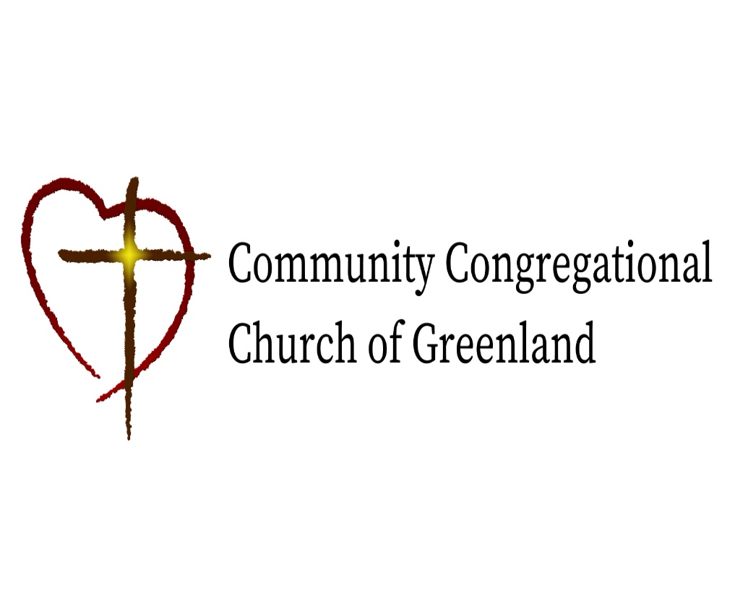

God calls us together to welcome all
and to serve God, each other, this community,
and the world
in the spirit of Christ’s love.
❖ All are welcome! 

