Welcome to Worship!
January 21, 2024 Epiphany 3B
Greeting and Call to Worship
Prelude

*Responsive Call to Worship based on psalm Ps 62: 5-12
Leader: For God alone my soul waits in silence; for my hope is
from him.
People: He alone is my rock and my salvation, my fortress; I
shall never be shaken.
Leader: On God rests my deliverance and my honor; my mighty
rock, my refuge is in God.
People: Trust in him at all times, O people; pour out your
heart before him; God is a refuge for us. Selah
Leader: Those of low estate are but a breath; those of high estate
are a delusion; in the balances they go up; they are
together lighter than a breath.
People: Put no confidence in extortion, and set no vain hopes
on robbery; if riches increase, do not set your heart
on them.
Leader: Once God has spoken; twice have I heard this: that power
belongs to God,
People: and steadfast love belongs to you, O Lord. For you
repay to all according to their work.

Opening Hymn: "Spirit, Working in Creation" No. 128

*Unison Prayer of Invocation and Lord’s Prayer (debts)
Lord, we hear your Son's invitation and see how it changes lives. Why do we hesitate to follow when we know Jesus' presence and purpose holds such abundant grace? Help us not just to hear, but to follow in Jesus' way, just as he invited us when he taught us to pray, saying...Our Father, who art in heaven, hallowed be thy name. Thy kingdom come, thy will be done on earth as it is in heaven. Give us this day our daily bread, and forgive us our debts, as we forgive our debtors. And lead us not into temptation, but deliver us from evil. For thine is the kingdom, and the power, and the glory forever.
Amen
*Gloria Patri No. 734
Glory be to the Creator, and to the Christ: And to the Holy Ghost;
As it was in the beginning, is now and ever shall be: world without end. Amen.

Choir Anthem

Reading of the Word Mark 1:14-20

Sermon God Calling

Meditation Hymn: "Day by Day" No. 449

Prayers of the People

Call For The Offering
Offertory
You may also mail your offering (P.O. Box 128, Greenland, NH 03840); Give on line by going to greenlanducc.org and click "Donate" tab. Thank you!

*Doxology No. 34
Praise God, from whom all blessings flow:
Praise God, all creatures here below.
Praise God above, ye heavenly host;
Creator, Christ, and Holy Ghost. Amen
*Prayer of Dedication

*Closing Hymn: "Rejoice, Ye Pure in Heart" No. 113

*Benediction

Postlude

*Please stand if you are able.

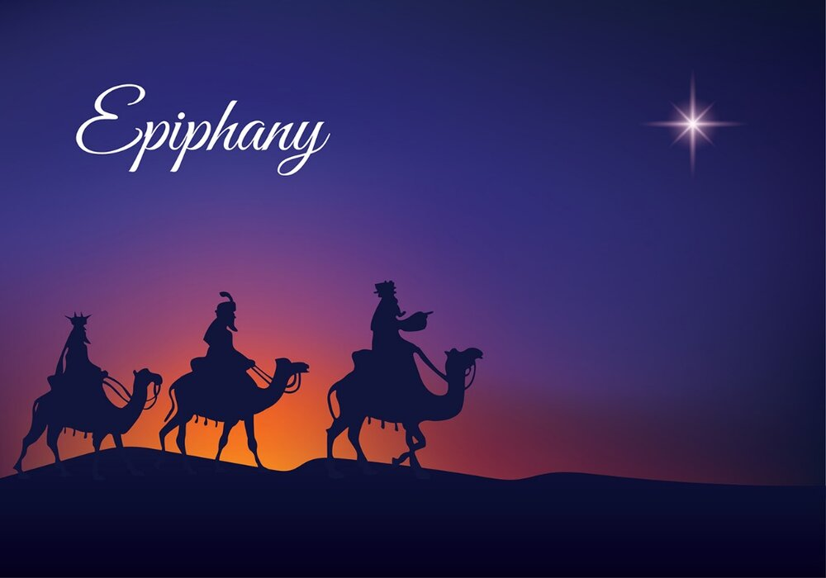

The liturgist is George Becker.
The Greeters/Ushers this Sunday are Sherri and George Becker.
This Sunday's flowers are given by Barbara Stone in memory of Rance Collins.

Community Congregational Church (UCC)
Greenland, New Hampshire
Gathered in 1706
Pastor: Rev. Mark C. Brockmeier
Music Director: Adelyn Nelson

Ministers: All the members of this congregation
Follow us on Facebook: https://www.facebook.com/cccgreenland
Church Office: 44 Post Rd. Open Wednesdays 12-7
PO Box 128 Greenland NH 03840
603-436-8336, greenlanducc@myfairpoint.net
Rev. Mark Brockmeier email: revbrock@bu.edu
Mobile: 603-818-2328

January 21, 2024 Epiphany 3B
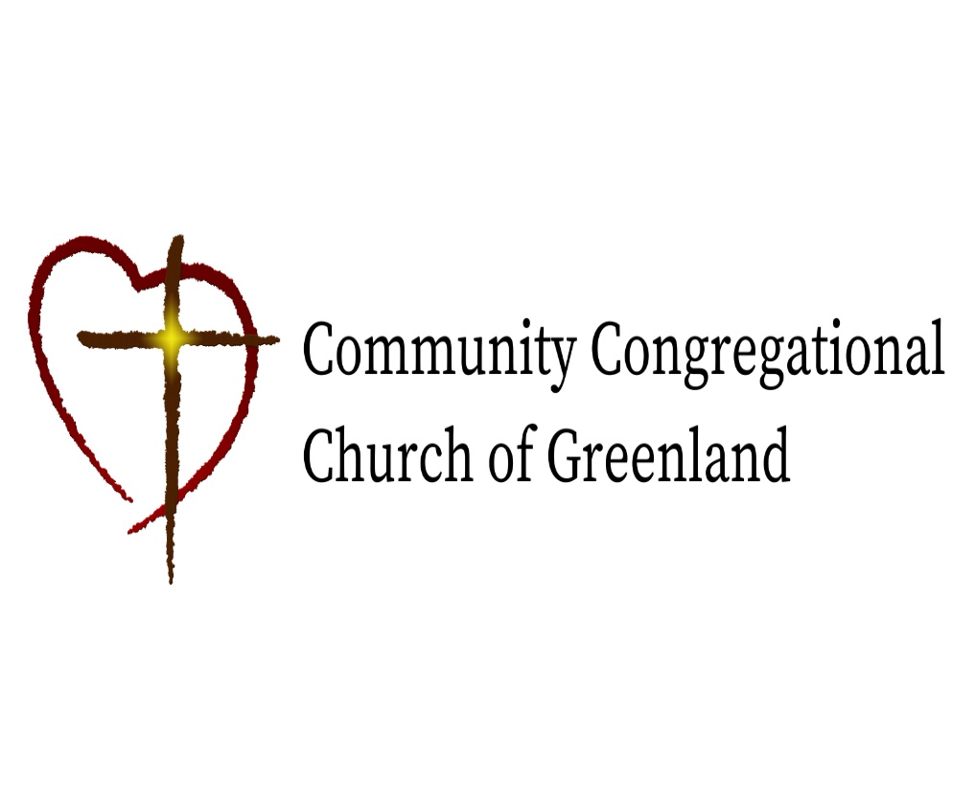

God calls us together to welcome all
and to serve God, each other, this community,
and the world
in the spirit of Christ’s love.
❖ All are welcome! 

