Welcome to Worship!
December 03, 2023 Advent 1B
Greeting and Call to Worship
Advent Candle of Peace Lighting #175 V. 1, 2 By Cynthia Smith and Barbara Stone, confirmation class of 1952 and longtime friends.
Prelude Hanging of the Ornaments
*Responsive Call to Worship based on psalm Ps 80: 1-7
Leader: Give ear, O Shepherd of Israel, you who lead Joseph like
a flock! You who are enthroned upon the cherubim, shine
forth
People: before Ephraim and Benjamin and Manasseh.
Stir up your might, and come to save us!
Leader: Restore us, O God; let your face shine, that we may be
saved.
People: O Lord God of hosts, how long will you be angry with
your people’s prayers?
Leader: You have fed them with the bread of tears and given
them tears to drink in full measure.
People: You make us the scorn of our neighbors; our
enemies laugh among themselves.
Leader: Restore us, O God of hosts; let your face shine, that we
may be saved.

Opening Hymn: "O Come, O Come, Emmanuel" No. 154

*Unison Prayer of Invocation and Lord’s Prayer (debts)
Lord, we thank you for the days that we have here, that we know not how many, but that they be lived with mercy, compassion, kindness, justice, and most of all love, that love which your Son gave us when he taught us to pray, saying..., Our Father, who art in heaven, hallowed be thy name. Thy kingdom come, thy will be done on earth as it is in heaven. Give us this day our daily bread, and forgive us our debts, as we forgive our debtors. And lead us not into temptation, but deliver us from evil. For thine is the kingdom, and the power, and the glory forever.
Amen

*Gloria Patri No. 734
Glory be to the Creator, and to the Christ: And to the Holy Ghost;
As it was in the beginning, is now and ever shall be: world without end. Amen.

Choir Anthem

Reading of the Word Mark 13:24-37

Sermon How Do We Know?

Meditation Hymn: "It Came Upon the Midnight Clear" No. 191

Prayers of the People

Call For The Offering
Offertory
You may also mail your offering (P.O. Box 128, Greenland, NH 03840); Give on line by going to greenlanducc.org and click "Donate" tab. Thank you!

*Doxology No. 34
Praise God, from whom all blessings flow:
Praise God, all creatures here below.
Praise God above, ye heavenly host;
Creator, Christ, and Holy Ghost. Amen

*Prayer of Dedication

*Closing Hymn: "When We All Get to Heaven" No. 525

*Benediction
Postlude

*Please stand if you are able.

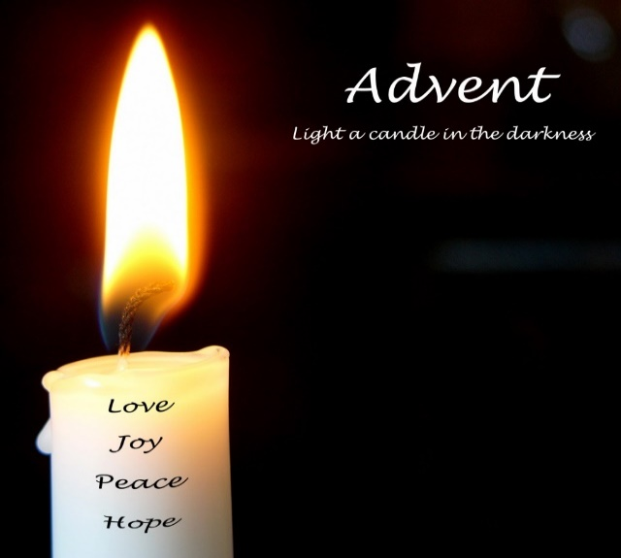

The liturgist is Glenn Bergeron.
The Greeters/Ushers this Sunday are Barbara and John Fletcher.

Community Congregational Church (UCC)
Greenland, New Hampshire
Gathered in 1706
Pastor: Rev. Mark C. Brockmeier
Music Director: Adelyn Nelson

Ministers: All the members of this congregation
Follow us on Facebook: https://www.facebook.com/cccgreenland
Church Office: 44 Post Rd. Open Wednesdays 12-7
PO Box 128 Greenland NH 03840
603-436-8336, greenlanducc@myfairpoint.net
Rev. Mark Brockmeier email: revbrock@bu.edu
Mobile: 603-818-2328

December 03, 2023 Advent 1B
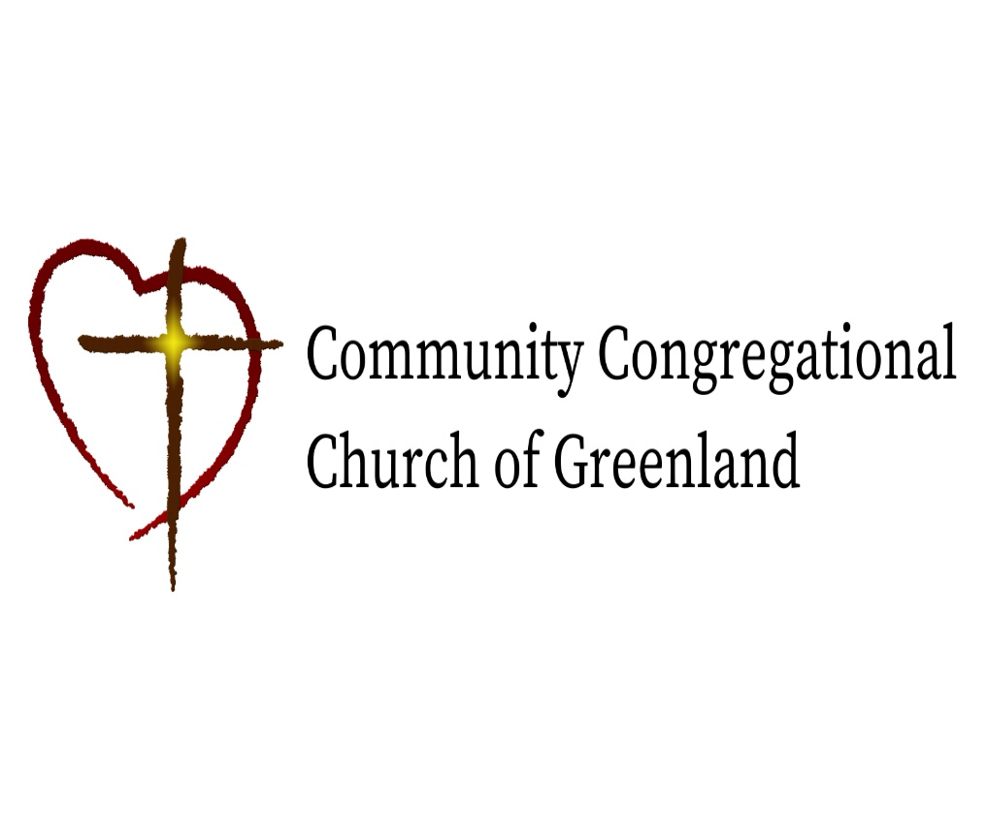

God calls us together to welcome all
and to serve God, each other, this community,
and the world
in the spirit of Christ’s love.
❖ All are welcome! 

