Welcome to Worship!

November 6, 2022 Proper 27
COMMUNION SUNDAY
Greetings and Announcements
Prelude "Miserere" William Byrd

*Responsive Call to Worship based on psalm 98: 1-6
Leader: O sing to the Lord a new song, for he has done
Marvelous things. His right hand and his holy arm have
gotten him victory.
People: The Lord has made known his victory; he has
revealed his vindication in the sight of the nations.
Leader: He has remembered his steadfast love and faithfulness
to the house of Israel. All the ends of the earth have seen
the victory of our God.
People: Make a joyful noise to the Lord, all the earth;
break forth into joyous song and sing praises.
Leader: Sing praises to the Lord with the lyre, with the lyre and
the sound of melody.
People: With trumpets and the sound of the horn make a
joyful noise before the King, the Lord.

Opening Hymn: "Lead on, O King Eternal" No. 508

*Unison Prayer of Invocation and Lord’s Prayer (debts)
Lord, we don't always understand what new life means. Give us the wisdom to know that it is union with you that is our life's work and purpose, not the accumulation of our own lives. Help us to help others understand this divine love, as did your Son when he taught us to pray, saying....Our Father, who art in heaven, hallowed be thy name. Thy kingdom come, thy will be done on earth as it is in heaven. Give us this day our daily bread, and forgive us our debts, as we forgive our debtors. And lead us not into temptation, but deliver us from evil. For thine is the kingdom, and the power, and the glory forever. Amen
*Gloria Patri No. 734
Glory be to the Creator, and to the Christ: And to the Holy Ghost;
As it was in the beginning, is now and ever shall be: world without end. Amen.

choir anthem "We Gather Together"

Reading of the Word Luke 20: 27-38

Sermon Honesty is the Best Policy

Meditation Hymn: "All the Way My Savior Leads Me" No. 505

Prayers of the People
Holy Communion
Call For The Offering

Offertory "Close to Thee"

You may also mail your offering (P.O. Box 128, Greenland, NH 03840); Give on line by going to greenlanducc.org and click "Donate" tab. Thank you!

*Doxology No. 34
Praise God, from whom all blessings flow:
Praise God, all creatures here below.
Praise God above, ye heavenly host;
Creator, Christ, and Holy Ghost. Amen
*Prayer of Dedication

*Closing Hymn: "Rejoice, Ye Pure in Heart" No. 113

*Benediction

Postlude "Guide Me, O Though Great Jehovah"

*Please stand if you are able.

The liturgist is Bonnie Gardner.
The Greeters/Ushers this Sunday are Bonnie Gardner and Barbara Stone.
This Sunday's flowers are given by the Perriccio family in honor of Veterans Day.

Community Congregational Church (UCC)
Greenland, New Hampshire
Gathered in 1706
Pastor: Rev. Mark C. Brockmeier
Music Director: Sam Partyka
Ministers: All the members of this congregation
Follow us on Facebook: https://www.facebook.com/cccgreenland
Church Office: 44 Post Rd. Open Wednesdays 12-7
PO Box 128 Greenland NH 03840
603-436-8336, greenlanducc@myfairpoint.net
Rev. Mark Brockmeier email: revbrock@bu.edu
Mobile: 603-818-2328

November 6, 2022 Proper 27
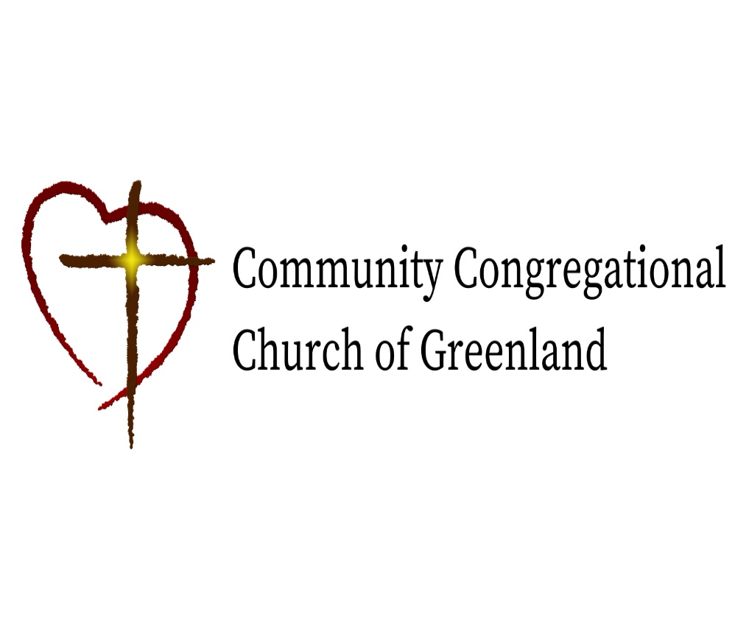

God calls us together to welcome all
and to serve God, each other, this community,
and the world
in the spirit of Christ’s love.
❖ All are welcome! 

