Welcome to Worship!

October 23, 2022 Proper 25
Greetings and Announcements
Prelude "Presto" Clementi

*Responsive Call to Worship based on psalm 65: 1-8
Leader: Praise is due to you, O God, in Zion, and to you shall
vows be performed,
People: O you who answer prayer! To you all flesh shall
come.
Leader: When deeds of iniquity overwhelm us, you forgive our
transgressions.
People: Happy are those whom you choose and bring near
to live in your courts. We shall be satisfied with the
goodness of your house, your holy temple.
Leader: By awesome deeds you answer us with deliverance,
O God of our salvation; you are the hope of all the ends
of the earth and of the farthest seas.
People: By your strength you established the mountains;
you are girded with might.
Leader: You silence the roaring of the seas, the roaring of their
waves, the tumult of the peoples.
People: Those who live at earth’s farthest bounds are awed
by your signs; you make the gateways of the morning
and the evening shout for joy.

Opening Hymn: "And Can it Be" No. 366

*Unison Prayer of Invocation and Lord’s Prayer (debts)
Lord, we ask for forgiveness yet have trouble accepting it, let alone forgiving ourselves. Help us to understand your love is given so that we might be more whole, just as Jesus promised when he taught us to pray saying...Our Father, who art in heaven, hallowed be thy name. Thy kingdom come, thy will be done on earth as it is in heaven. Give us this day our daily bread, and forgive us our debts, as we forgive our debtors. And lead us not into temptation, but deliver us from evil. For thine is the kingdom, and the power, and the glory forever. Amen
*Gloria Patri No. 734
Glory be to the Creator, and to the Christ: And to the Holy Ghost;
As it was in the beginning, is now and ever shall be: world without end. Amen.

choir anthem "Abide With Me"

Reading of the Word Luke 18: 9-14

Sermon I and Thou

Meditation Hymn: "Take My Life and Let it Be" No. 466

Prayers of the People
Call For The Offering

Offertory "Be Thou My Vision" Raney

You may also mail your offering (P.O. Box 128, Greenland, NH 03840); Give on line by going to greenlanducc.org and click the "Donate" tab. Thank you!

*Doxology No. 34
Praise God, from whom all blessings flow:
Praise God, all creatures here below.
Praise God above, ye heavenly host;
Creator, Christ, and Holy Ghost. Amen
*Prayer of Dedication

*Closing Hymn: "Guide Me, O Thou Great Jehovah"
No. 501
*Benediction

Postlude "God Leads Us Along" Arnold

*Please stand if you are able.

The liturgist is Karen Mason.
The Greeters/Ushers this Sunday are Joanne Spradlin and
Beverly Perriccio.
This Sunday's flowers are donated by Karen and Fred Mason in honor of work done by small liberal arts colleges everywhere.

Community Congregational Church (UCC)
Greenland, New Hampshire
Gathered in 1706
Pastor: Rev. Mark C. Brockmeier
Music Director: Sam Partyka
Ministers: All the members of this congregation
Follow us on Facebook: https://www.facebook.com/cccgreenland
Church Office: 44 Post Rd. Open Wednesdays 12-7
PO Box 128 Greenland NH 03840
603-436-8336, greenlanducc@myfairpoint.net
Rev. Mark Brockmeier email: revbrock@bu.edu
Mobile: 603-818-2328

October 23, 2022 Proper 25
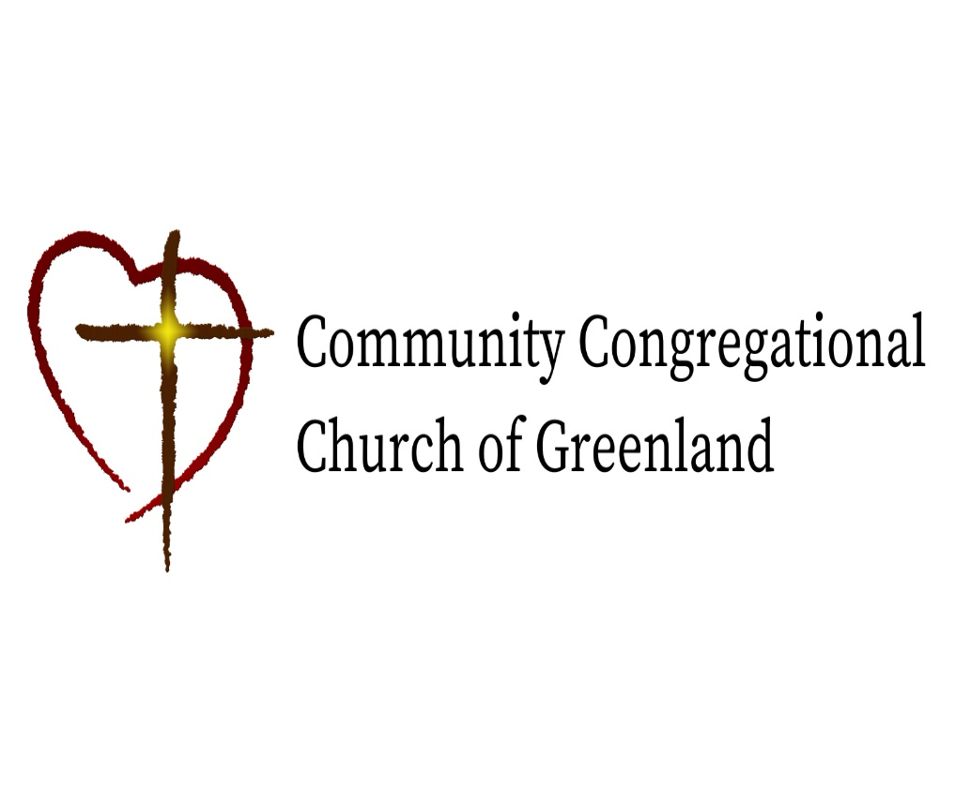

God calls us together to welcome all
and to serve God, each other, this community,
and the world
in the spirit of Christ’s love.
❖ All are welcome! 

