Welcome to Worship!

October 16, 2022 Proper 24

Greetings and Announcements
Prelude "Etude in A-flat Major" Chopin

*Responsive Call to Worship based on psalm 119: 97-105
Leader: Oh, how I love your law! It is my meditation all day
long.
People: Your commandment makes me wiser than my
enemies, for it is always with me.
Leader: I hold back my feet from every evil way, in order to keep
your word.
People: I do not turn away from your ordinances, for you
have taught me.
Leader: How sweet are your words to my taste, sweeter than
honey to my mouth!
People: Through your precepts I get understanding;
therefore I hate every false way.
Leader: Your word is a lamp to my feet and a light to my path.

Opening Hymn: "O God, Our Help In Ages Past" No. 84

*Unison Prayer of Invocation and Lord’s Prayer (debts)
Lord, we come to you wanting lots of things in and for our lives. Remind us that your love gives us the resilience to forebear all circumstances, and to be grateful just for our being this day, that lesson which Jesus gave us when he taught us to pray, saying....Our Father, who art in heaven, hallowed be thy name. Thy kingdom come, thy will be done on earth as it is in heaven. Give us this day our daily bread, and forgive us our debts, as we forgive our debtors. And lead us not into temptation, but deliver us from evil. For thine is the kingdom, and the power, and the glory forever. Amen

*Gloria Patri No. 734
Glory be to the Creator, and to the Christ: And to the Holy Ghost;
As it was in the beginning, is now and ever shall be: world without end. Amen.

choir anthem "Creating God Your Fingers Trace"

Reading of the Word Luke 18: 1-8

Sermon Justice is a dish best served...

Meditation Hymn: "Just As I Am" No. 354

Prayers of the People
Call For The Offering

Offertory "All Creatures of Our God and King" Sanborn

You may also mail your offering (P.O. Box 128, Greenland, NH 03840); Give on line by going to greenlanducc.org and click the "Donate" tab. Thank you!

*Doxology No. 34
Praise God, from whom all blessings flow:
Praise God, all creatures here below.
Praise God above, ye heavenly host;
Creator, Christ, and Holy Ghost. Amen
*Prayer of Dedication

*Closing Hymn: "If You Will Trust in God To Guide You"
No. 429
*Benediction

Postlude "All Hail the Pow'r of Jesus' Name" Sanborn

*Please stand if you are able.

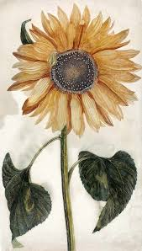

The liturgist is Mark Weaver.
The Greeters/Ushers this Sunday are Dick Hazzard and John Weeks.
This Sunday's flowers are donated by Barbara and John Fletcher in celebration of October birthdays.

Community Congregational Church (UCC)
Greenland, New Hampshire
Gathered in 1706
Pastor: Rev. Mark C. Brockmeier
Music Director: Sam Partyka
Ministers: All the members of this congregation
Follow us on Facebook: https://www.facebook.com/cccgreenland
Church Office: 44 Post Rd. Open Wednesdays 12-7
PO Box 128 Greenland NH 03840
603-436-8336, greenlanducc@myfairpoint.net
Rev. Mark Brockmeier email: revbrock@bu.edu
Mobile: 603-818-2328

October 16, 2022 Proper 24
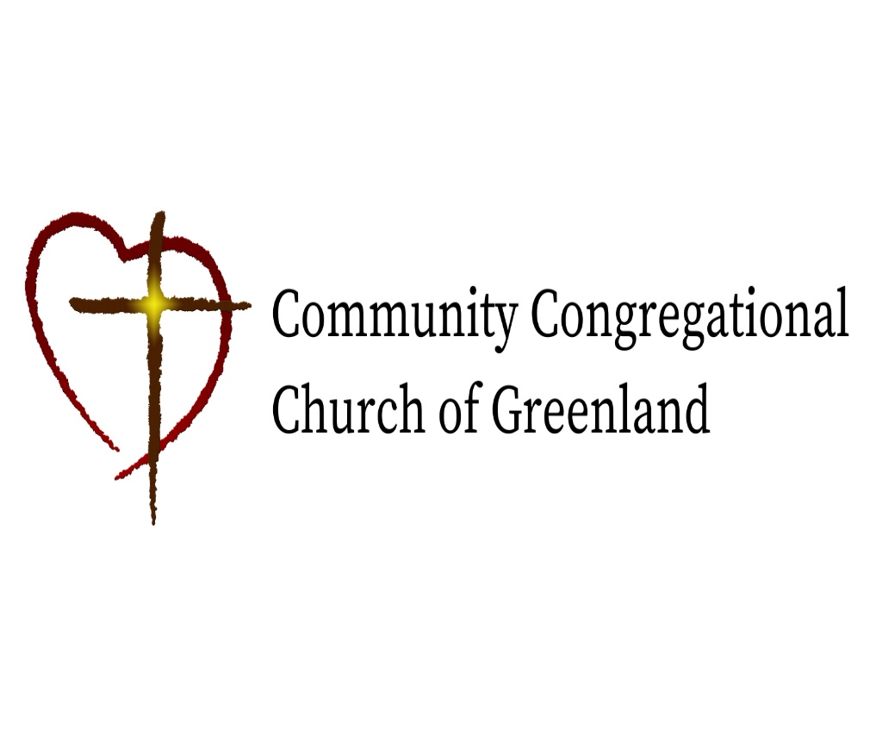

God calls us together to welcome all
and to serve God, each other, this community,
and the world
in the spirit of Christ’s love.
❖ All are welcome! 

