Welcome to Worship!

October 9, 2022 Proper 23
COMMUNION SUNDAY
Greetings and Announcements
Prelude "Improvisation" MacDowell

*Responsive Call to Worship based on psalm 66: 1-7
Leader: Make a joyful noise to God, all the earth;
People: sing the glory of his name; give to him glorious praise.
Leader: Say to God, “How awesome are your deeds! Because of
your great power, your enemies cringe before you.
People: All the earth worships you; they sing praises to you,
sing praises to your name.” Selah
Leader: Come and see what God has done: he is awesome in his
deeds among mortals.
People: He turned the sea into dry land; they passed through
the river on foot. There we rejoiced in him,
Leader: who rules by his might forever, whose eyes keep watch
on the nations—let the rebellious not exalt themselves.
Selah

Opening Hymn: "O, For a Thousand Tongues" No. 96

*Unison Prayer of Invocation and Lord’s Prayer (debts)
Lord, we like our lives to be ordered and predictable. But the world keeps pressing in on us, forcing us to make choices in our lives to adapt. Help us to cross spaces which scare us, to take on new choices and perspectives in loving one another, just as your Son did when he taught us to pray, saying....Our Father, who art in heaven, hallowed be thy name. Thy kingdom come, thy will be done on earth as it is in heaven. Give us this day our daily bread, and forgive us our debts, as we forgive our debtors. And lead us not into temptation, but deliver us from evil. For thine is the kingdom, and the power, and the glory forever. Amen

*Gloria Patri No. 734
Glory be to the Creator, and to the Christ: And to the Holy Ghost;
As it was in the beginning, is now and ever shall be: world without end. Amen.

choir anthem "Sing Praise to God"

Reading of the Word Luke 17: 11-19

Sermon Wounds of the Past and Present

Meditation Hymn: "My Faith Looks Up to Thee" No. 419

Prayers of the People
Holy Communion
Call For The Offering

Offertory "Land of Rest" Page

You may also mail your offering (P.O. Box 128, Greenland, NH 03840); Give on line by going to greenlanducc.org and click the "Donate" tab. Thank you!

*Doxology No. 34
Praise God, from whom all blessings flow:
Praise God, all creatures here below.
Praise God above, ye heavenly host;
Creator, Christ, and Holy Ghost. Amen
*Prayer of Dedication

*Closing Hymn: "On Jordan's Stormy Banks" No. 519

*Benediction

Postlude "Marching to Zion" Broughton

*Please stand if you are able.

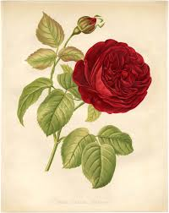

The liturgist is Glenn Bergeron.
The Greeters/Ushers this Sunday are Joanne and Chris Shultz.
This Sunday's flowers are donated by Marie Hussey in honor of her son, Joshua’s birthday.

Community Congregational Church (UCC)
Greenland, New Hampshire
Gathered in 1706
Pastor: Rev. Mark C. Brockmeier
Music Director: Sam Partyka
Ministers: All the members of this congregation
Follow us on Facebook: https://www.facebook.com/cccgreenland
Church Office: 44 Post Rd. Open Wednesdays 12-7
PO Box 128 Greenland NH 03840
603-436-8336, greenlanducc@myfairpoint.net
Rev. Mark Brockmeier email: revbrock@bu.edu
Mobile: 603-818-2328

October 9, 2022 Proper 23
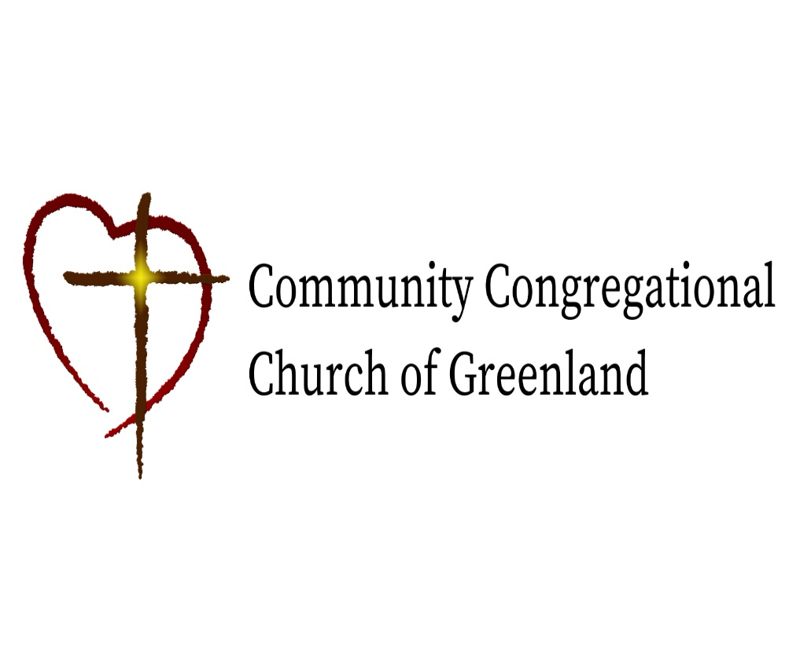

God calls us together to welcome all
and to serve God, each other, this community,
and the world
in the spirit of Christ’s love.
❖ All are welcome! 

