Welcome to Worship!

August 28, 2022 Proper 17

Greetings and Announcements
Prelude "Prelude in B Minor" Bach

*Responsive Call to Worship based on psalm 112: 1-8
Leader: Praise the Lord! Happy are those who fear the Lord,
who greatly delight in his commandments.
People: Their descendants will be mighty in the land;
the generation of the upright will be blessed.
Leader: Wealth and riches are in their houses, and their
righteousness endures forever.
People: They rise in the darkness as a light for the upright;
they are gracious, merciful, and righteous.
Leader: It is well with those who deal generously and lend,
who conduct their affairs with justice.
People: For the righteous will never be moved; they will be
remembered forever.
Leader: They are not afraid of evil tidings; their hearts are firm,
secure in the Lord.
People: Their hearts are steady; they will not be afraid;
in the end they will look in triumph on their foes.

Opening Hymn: "All Things Bright and Beautiful" No. 30

*Unison Prayer of Invocation and Lord’s Prayer (debts)
Lord, we want to serve but don't know how. Give us the humility and grace to reach outside our social boundaries. Help us to love ourselves so that we can be last at the table, just as Christ did when he taught us to pray by saying,...Our Father, who art in heaven, hallowed be thy name. Thy kingdom come, thy will be done on earth as it is in heaven. Give us this day our daily bread, and forgive us our debts, as we forgive our debtors. And lead us not into temptation, but deliver us from evil. For thine is the kingdom, and the power, and the glory forever. Amen

*Gloria Patri No. 734
Glory be to the Creator, and to the Christ: And to the Holy Ghost;
As it was in the beginning, is now and ever shall be: world without end. Amen.

Reading of the Word Luke 14: 7-14

Sermon Dinner Party Politics

Meditation Hymn: "Search Me, O God" No. 385

Prayers of the People

Call For The Offering

Offertory "What a Friend We Have in Jesus"

You may also mail your offering (P.O. Box 128, Greenland, NH 03840); Give on line by going to greenlanducc.org and click the "Donate" tab. Thank you!

*Doxology No. 34
Praise God, from whom all blessings flow:
Praise God, all creatures here below.
Praise God above, ye heavenly host;
Creator, Christ, and Holy Ghost. Amen

*Prayer of Dedication

*Closing Hymn: "Let All Things Now Living" No. 22

*Benediction

Postlude "Give Thanks With a Grateful Heart" Sanborn

*Please stand if you are able.

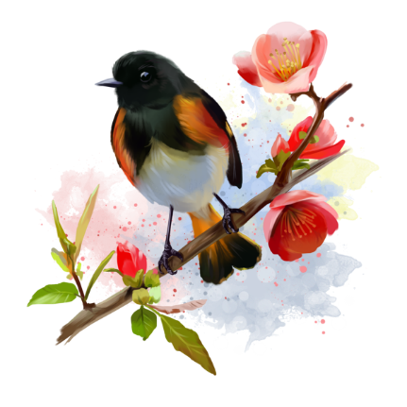

The liturgist is Thomas Bates.
The Greeters/Ushers this Sunday are Martha and Thomas Bates.
This Sunday's flowers are given by the Shultz’s in memory of Joanne’s brother, Alexander (Bud) Mackenzie.

Community Congregational Church (UCC)
Greenland, New Hampshire
Gathered in 1706
Pastor: Rev. Mark C. Brockmeier
Music Director: Sam Partyka
Ministers: All the members of this congregation
Follow us on Facebook: https://www.facebook.com/cccgreenland
Church Office: 44 Post Rd. Open Wednesdays 12-7
PO Box 128 Greenland NH 03840
603-436-8336, greenlanducc@myfairpoint.net
Rev. Mark Brockmeier email: revbrock@bu.edu
Mobile: 603-818-2328

August 28, 2022 Proper 17
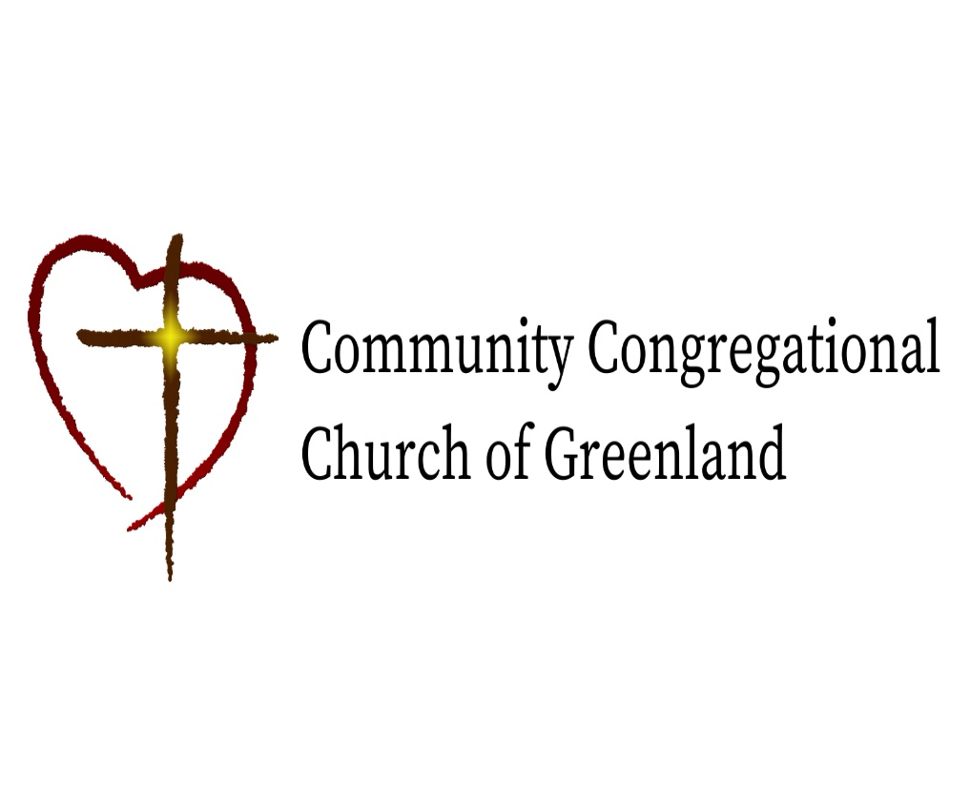

God calls us together to welcome all
and to serve God, each other, this community,
and the world
in the spirit of Christ’s love.
❖ All are welcome! 

