Welcome to Worship!

August 21, 2022 Proper 16

Greetings and Announcements
Prelude "Prelude in G Major" J. S. Bach

*Responsive Call to Worship based on psalm 71: 1-6
Leader: In you, O Lord, I take refuge; let me never be put to
shame.
People: In your righteousness deliver me and rescue me;
incline your ear to me and save me.
Leader: Be to me a rock of refuge, a strong fortress to save me,
for you are my rock and my fortress.
People: Rescue me, O my God, from the hand of the wicked,
from the grasp of the unjust and cruel.
Leader: For you, O Lord, are my hope, my trust, O Lord, from
my youth.
People: From my birth I have leaned upon you, my protector
since my mother’s womb. My praise is continually of
you.

Opening Hymn: "In Christ There is no East or West"
No. 600

*Unison Prayer of Invocation and Lord’s Prayer (debts)
Lord, we are weighed down by burdens we impose on ourselves. We carry things in us that we should be giving to you. Grant us the freedom to release our burdens and be forgiven, just as when your Son did when he taught us to pray, saying....Our Father, who art in heaven, hallowed be thy name. Thy kingdom come, thy will be done on earth as it is in heaven. Give us this day our daily bread, and forgive us our debts, as we forgive our debtors. And lead us not into temptation, but deliver us from evil. For thine is the kingdom, and the power, and the glory forever. Amen
*Gloria Patri No. 734
Glory be to the Creator, and to the Christ: And to the Holy Ghost;
As it was in the beginning, is now and ever shall be: world without end. Amen.

Reading of the Word Luke 13: 10-17

Sermon Our Intended Purpose

Meditation Hymn: "There is a Balm in Gilead" No. 631

Prayers of the People

Call For The Offering

Offertory "He Lifted Me"

You may also mail your offering (P.O. Box 128, Greenland, NH 03840); Give on line by going to greenlanducc.org and click the "Donate" tab. Thank you!

*Doxology No. 34
Praise God, from whom all blessings flow:
Praise God, all creatures here below.
Praise God above, ye heavenly host;
Creator, Christ, and Holy Ghost. Amen

*Prayer of Dedication

*Closing Hymn: "God of Grace and God of Glory"
No. 569

*Benediction

Postlude "I Sing the Mighty Pow'r of God"

*Please stand if you are able.

The liturgist is Wendy Jones.
The Greeters/Ushers this Sunday are Wendy Jones and Beverly Perriccio.
This Sunday's flowers are given by Pastor Mark to celebrate his wife Kate’s birthday.

Community Congregational Church (UCC)
Greenland, New Hampshire
Gathered in 1706
Pastor: Rev. Mark C. Brockmeier
Music Director: Sam Partyka
Ministers: All the members of this congregation
Follow us on Facebook: https://www.facebook.com/cccgreenland
Church Office: 44 Post Rd. Open Wednesdays 12-7
PO Box 128 Greenland NH 03840
603-436-8336, greenlanducc@myfairpoint.net
Rev. Mark Brockmeier email: revbrock@bu.edu
Mobile: 603-818-2328

August 21, 2022 Proper 16
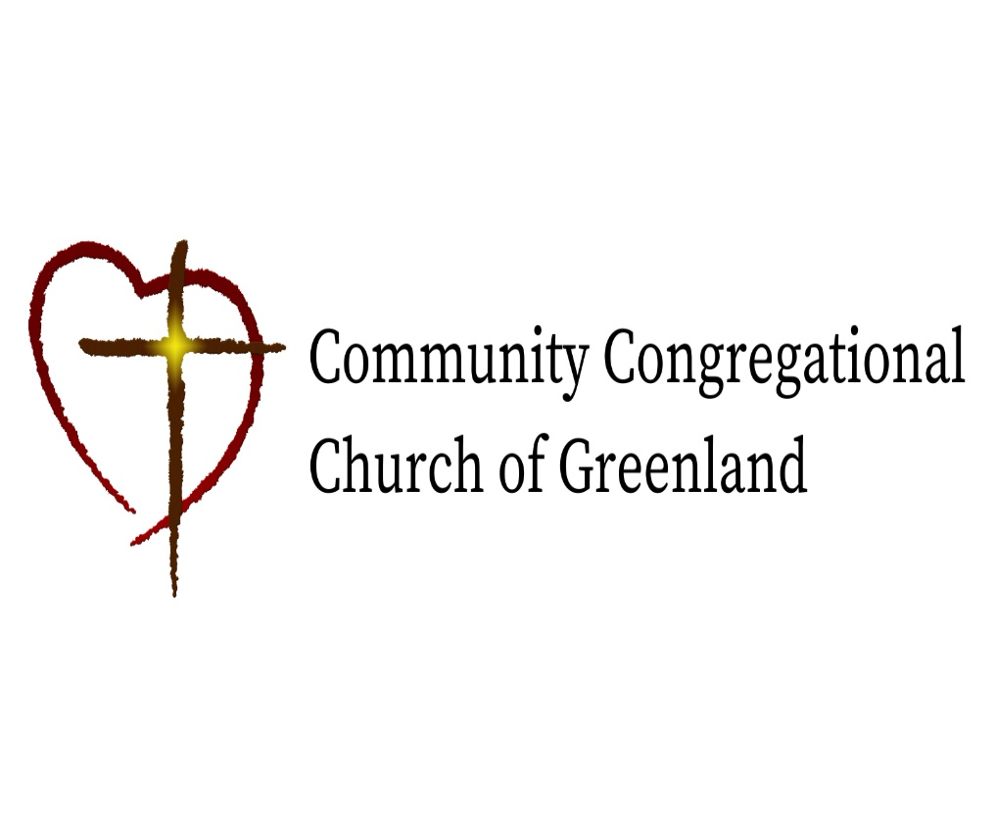

God calls us together to welcome all
and to serve God, each other, this community,
and the world
in the spirit of Christ’s love.
❖ All are welcome! 

