Welcome to Worship!

July 24, 2022 Proper 12
Greetings and Announcements
Prelude "Prelude in C# Minor" Chopin

*Responsive Call to Worship based on psalm 85: 1-7
Leader: Lord, you were favorable to your land; you restored the
fortunes of Jacob.
People: You forgave the iniquity of your people; you
pardoned all their sin. Selah
Leader: You withdrew all your wrath; you turned from your hot
anger.
People: Restore us again, O God of our salvation, and put
away your indignation toward us.
Leader: Will you be angry with us forever? Will you prolong
your anger to all generations?
People: Will you not revive us again, so that your people may
rejoice in you?
Leader: Show us your steadfast love, O Lord, and grant us your
salvation.

*Opening Hymn: "Open My Eyes, That I May See"
No. 480

*Unison Prayer of Invocation and Lord’s Prayer (debts)
Lord, we pray to you expecting our prayers are answered this day, in our way. Give us patient and humble hearts to know that just being heard is all that is needed, and that you hold us in your heart even in our darkest times. Let us speak plainly to you and through you, as Christ did when he taught us to pray, saying...Our Father, who art in heaven, hallowed be thy name. Thy kingdom come, thy will be done on earth as it is in heaven. Give us this day our daily bread, and forgive us our debts, as we forgive our debtors. And lead us not into temptation, but deliver us from evil. For thine is the kingdom, and the power, and the glory forever. Amen
*Gloria Patri No. 734
Glory be to the Creator, and to the Christ: And to the Holy Ghost;
As it was in the beginning, is now and ever shall be: world without end. Amen.

Reading of the Word Luke 11: 1-13

Sermon Thanks and Petitions

Meditation Hymn: "Have Thine Own Way" No. 486

Prayers of the People

Call For The Offering

Offertory "Just As I Am" Raney

You may also mail your offering (P.O. Box 128, Greenland, NH 03840); Give on line by going to greenlanducc.org and click the "Donate" tab. Thank you!

*Doxology No. 34
Praise God, from whom all blessings flow:
Praise God, all creatures here below.
Praise God above, ye heavenly host;
Creator, Christ, and Holy Ghost. Amen

*Prayer of Dedication

*Closing Hymn: "Leaning on the Everlasting Arms"
No. 496

*Benediction

Postlude "What a Friend We Have in Jesus" Schrader

*Please stand if you are able.

The liturgist is Kate White.
The Greeters/Ushers this Sunday are Kate White and Cynthia Smith.
This Sunday's flowers are given by Karen and Fred Mason in memory of her Dad on his birthday.

Community Congregational Church (UCC)
Greenland, New Hampshire
Gathered in 1706
Pastor: Rev. Mark C. Brockmeier
Music Director: Sam Partyka
Ministers: All the members of this congregation
Church School suspended until further notice.
Church Office: 44 Post Rd. Open Wednesdays 12-7
PO Box 128 Greenland NH 03840
603-436-8336, greenlanducc@myfairpoint.net
Rev. Mark Brockmeier email: revbrock@bu.edu
Mobile: 603-818-2328

July 24, 2022 Proper 12
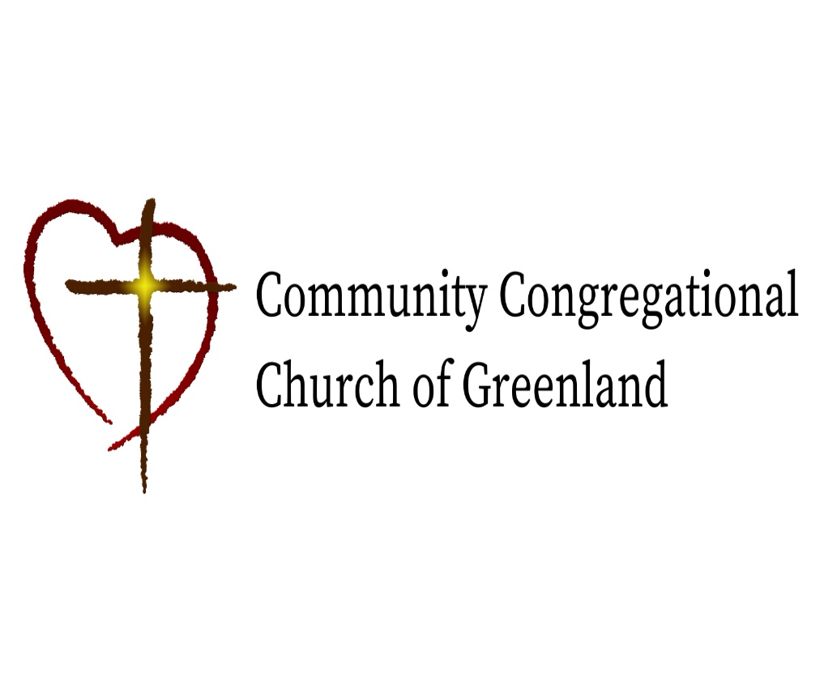

God calls us together to welcome all
and to serve God, each other, this community,
and the world
in the spirit of Christ’s love.
❖ All are welcome! 

