Welcome to Worship!

July 10, 2022 Pentecost 5c
Greetings and Announcements
Prelude "Serenade" Sinding

*Responsive Call to Worship based on psalm 82: 1-8
Leader: God has taken his place in the divine council; in the
midst of the gods he holds judgment:
People: “How long will you judge unjustly and show
partiality to the wicked? Selah
Leader: Give justice to the weak and the orphan; maintain the
right of the lowly and the destitute.
People: Rescue the weak and the needy; deliver them from
the hand of the wicked.”
Leader: They have neither knowledge nor understanding;
they walk around in darkness; all the foundations of the
earth are shaken.
People: I say, “You are gods, children of the Most High, all
of you;
Leader: nevertheless, you shall die like mortals and fall like any
prince.”
People: Rise up, O God, judge the earth, for all the nations
belong to you!

*Opening Hymn: "Stand Up and Bless the Lord" No. 11

*Unison Prayer of Invocation and Lord’s Prayer (debts)
Lord, grant us the eyes to see our neighbors. Not as we want them to be, but for who they are, right here, right now. Help us to love their very being, just as Christ loved us as he taught us to pray, saying,...Our Father, who art in heaven, hallowed be thy name. Thy kingdom come, thy will be done on earth as it is in heaven. Give us this day our daily bread, and forgive us our debts, as we forgive our debtors. And lead us not into temptation, but deliver us from evil. For thine is the kingdom, and the power, and the glory forever. Amen
*Gloria Patri No. 734
Glory be to the Creator, and to the Christ: And to the Holy Ghost;
As it was in the beginning, is now and ever shall be: world without end. Amen.

Reading of the Word Luke 10: 25-37

Sermon Get a Good Lawyer

Meditation Hymn: "O Master, Let Me Walk with Thee"
No. 589

Prayers of the People

Call For The Offering

Offertory "In the Garden" Sanborn

You may also mail your offering (P.O. Box 128, Greenland, NH 03840); Give on line by going to greenlanducc.org and click the "Donate" tab. Thank you!

*Doxology No. 34
Praise God, from whom all blessings flow:
Praise God, all creatures here below.
Praise God above, ye heavenly host;
Creator, Christ, and Holy Ghost. Amen

*Prayer of Dedication

*Closing Hymn: "Hope of the World" No. 404

*Benediction

Postlude "How Beautiful" Larson

*Please stand if you are able.

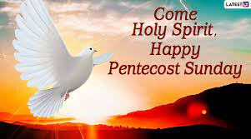

The liturgist is Joanne Shultz.
The Greeters/Ushers this Sunday are Chris and Joanne Shultz.
The flowers are fresh from Barbara Stone’s garden and in honor of Denice Perriccio’s birthday.

Community Congregational Church (UCC)
Greenland, New Hampshire
Gathered in 1706
Pastor: Rev. Mark C. Brockmeier
Music Director: Sam Partyka
Ministers: All the members of this congregation
Church School suspended until further notice.
Church Office: 44 Post Rd. Open Wednesdays 12-7
PO Box 128 Greenland NH 03840
603-436-8336, greenlanducc@myfairpoint.net
Rev. Mark Brockmeier email: revbrock@bu.edu
Mobile: 603-818-2328

July 10, 2022 Pentecost 5C
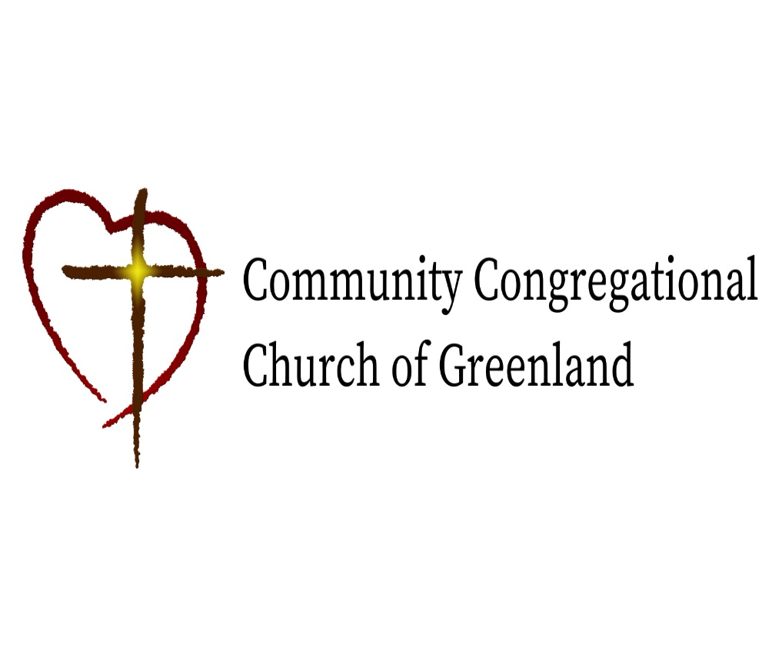

God calls us together to welcome all
and to serve God, each other, this community,
and the world
in the spirit of Christ’s love.
❖ All are welcome! 

