Welcome to Worship!

June 19, 2022 Pentecost 2c
Greetings and Announcements
Prelude "Con Velocita" Clementi

*Responsive Call to Worship based on psalm 22: 22-28
Leader: I will tell of your name to my brothers and sisters; in the
midst of the congregation I will praise you:
People: You who fear the Lord, praise him! All you
offspring of Jacob, glorify him; stand in awe of him,
all you offspring of Israel!
Leader: For he did not despise or abhor the affliction of the
afflicted; he did not hide his face from me but heard
when I cried to him.
People: From you comes my praise in the great congregation;
my vows I will pay before those who fear him.
Leader: The poor shall eat and be satisfied; those who seek him
shall praise the Lord. May your hearts live forever!
People: All the ends of the earth shall remember and turn to
the Lord, and all the families of the nations shall
worship before him.
Leader: For dominion belongs to the LORD, and he rules over
the nations.

*Opening Hymn: "Eternal Father, Strong to Save" No. 74

*Unison Prayer of Invocation and Lord’s Prayer (debts)
Lord, help us to see that we have privilege in our lives, and let us see more clearly those still in chains in our midst. Don't let us remain complacent, but fill us with compassion that we might invite you to stay among us, heal us, and lead us to greater acts of mercy and love, as did your Son when he taught us to pray saying....Our Father, who art in heaven, hallowed be thy name. Thy kingdom come, thy will be done on earth as it is in heaven. Give us this day our daily bread, and forgive us our debts, as we forgive our debtors. And lead us not into temptation, but deliver us from evil. For thine is the kingdom, and the power, and the glory forever. Amen

*Gloria Patri No. 734
Glory be to the Creator, and to the Christ: And to the Holy Ghost;
As it was in the beginning, is now and ever shall be: world without end. Amen.

Reading of the Word Luke 8: 26-39

Sermon "Free At Last"

Meditation Hymn: "Day By Day" No. 449

Prayers of the People

Call For The Offering

Offertory "Great is Thy Faithfulness" Shackley

You may also mail your offering (P.O. Box 128, Greenland, NH 03840); Give on line by going to greenlanducc.org and click the "Donate" tab. Thank you!

*Doxology No. 34
Praise God, from whom all blessings flow:
Praise God, all creatures here below.
Praise God above, ye heavenly host;
Creator, Christ, and Holy Ghost. Amen
*Prayer of Dedication

*Closing Hymn: "Great Is Thy Faithfulness" No. 72

*Benediction

Postlude "Promised Land" Sanborn

*Please stand if you are able.

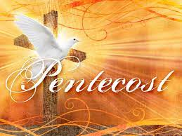

The liturgist is Mark Weaver.
The Greeters/Ushers this week are Bonnie Gardner and
Barbara Stone.
The flowers are given by Louise Thaden in memory of her husband, Bill.

Community Congregational Church (UCC)
Greenland, New Hampshire
Gathered in 1706
Pastor: Rev. Mark C. Brockmeier
Music Director: Sam Partyka
Ministers: All the members of this congregation
Church School suspended until further notice.
Church Office: 44 Post Rd. Open Wednesdays 12-7
PO Box 128 Greenland NH 03840
603-436-8336, greenlanducc@myfairpoint.net
Rev. Mark Brockmeier email: revbrock@bu.edu
Mobile: 603-818-2328

June 19, 2022 Pentecost 2C
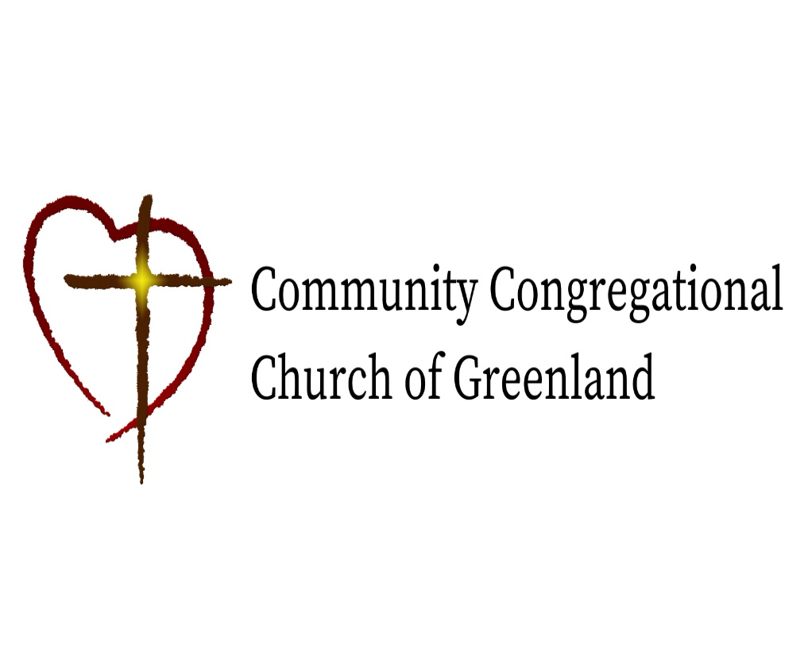

God calls us together to welcome all
and to serve God, each other, this community,
and the world
in the spirit of Christ’s love.
❖ All are welcome! 

