Welcome to Worship!

May 29, 2022 Easter 7C

Greetings and Announcements
Prelude "The Happy Farmer Returning from His Work"
Schumann

*Responsive Call to Worship based on psalm 97: 1-6, 12
Leader: The Lord is king! Let the earth rejoice; let the many
coastlands be glad!
People: Clouds and thick darkness are all around him;
righteousness and justice are the foundation of his
throne.
Leader: Fire goes before him and consumes his adversaries on
every side.
People: His lightnings light up the world; the earth sees and
trembles.
Leader: The mountains melt like wax before the Lord, before the
Lord of all the earth.
People: The heavens proclaim his righteousness, and all the
peoples behold his glory.
Leader: Rejoice in the Lord, O you righteous, and give thanks to
his holy name!

*Opening Hymn: "Sing Praise to God" No. 56

*Unison Prayer of Invocation and Lord’s Prayer (debts)
Lord, on this day of memory for those who are no longer with us, remind us of your presence through us. Keep us ever in your hand, that together may we encourage one another so that we may persevere in building your Kingdom, that Kingdom your Son spoke of when he prayed, saying....Our Father, who art in heaven, hallowed be thy name. Thy kingdom come, thy will be done on earth as it is in heaven. Give us this day our daily bread, and forgive us our debts, as we forgive our debtors. And lead us not into temptation, but deliver us from evil. For thine is the kingdom, and the power, and the glory forever. Amen

*Gloria Patri No. 734
Glory be to the Creator, and to the Christ: And to the Holy Ghost;
As it was in the beginning, is now and ever shall be: world without end. Amen.

choir anthem "I Will Sing of my Redeemer"

Reading of the Word Acts 16: 16-34

Sermon "Breaking Our Chains"

Meditation Hymn: "I Will Sing of the Mercies of the Lord"
No. 60
Prayers of the People

Call For The Offering

Offertory "I Sing the Mighty Power of God"

You may also mail your offering (P.O. Box 128, Greenland, NH 03840); Give on line by going to greenlanducc.org and click the "Donate" tab. Thank you!

*Doxology No. 34
Praise God, from whom all blessings flow:
Praise God, all creatures here below.
Praise God above, ye heavenly host;
Creator, Christ, and Holy Ghost. Amen
*Prayer of Dedication

*Closing Hymn: "All Creatures of our God and King" No. 23

*Benediction

Postlude "Come Christians, Join to Sing" Mayo

*Please stand if you are able.

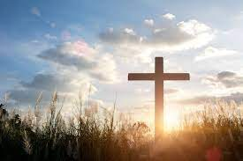

The liturgist is Beverly Perriccio.
The Greeters/Ushers this week are Joanne Spradlin and Beverly Perriccio.
The flowers are given by the Perriccio family in honor of all who have lost their lives in service to their country.

Community Congregational Church (UCC)
Greenland, New Hampshire
Gathered in 1706
Pastor: Rev. Mark C. Brockmeier
Music Director: Sam Partyka
Ministers: All the members of this congregation
Church School suspended until further notice.
Church Office: 44 Post Rd. Open Wednesdays 12-7
PO Box 128 Greenland NH 03840
603-436-8336, greenlanducc@myfairpoint.net
Rev. Mark Brockmeier email: revbrock@bu.edu
Mobile: 603-818-2328

May 29, 2022 Easter 7C
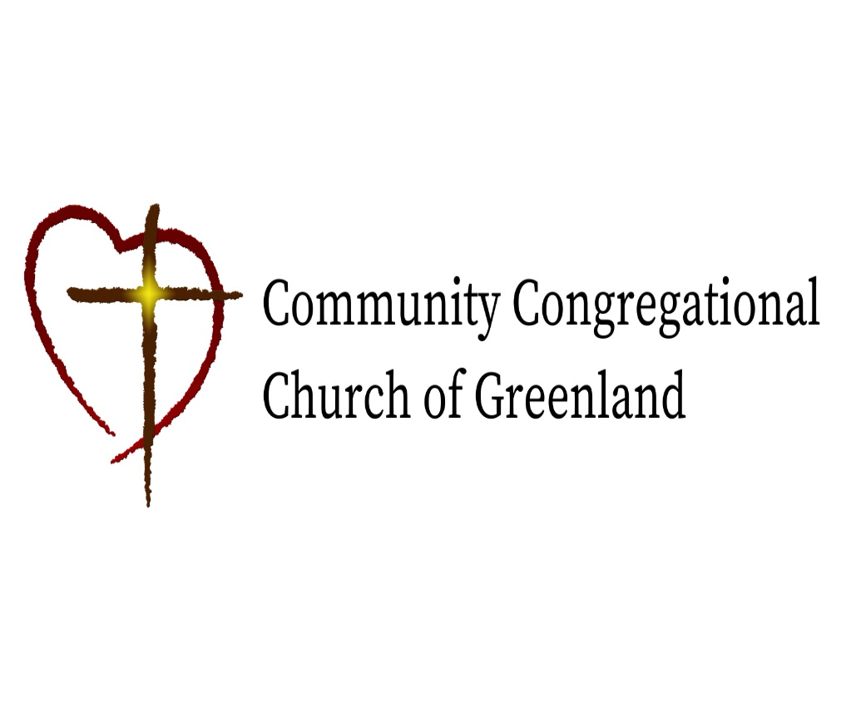

God calls us together to welcome all
and to serve God, each other, this community,
and the world
in the spirit of Christ’s love.
❖ All are welcome! 

