Welcome to Worship!

May 22, 2022 Easter 6C

Greetings and Announcements
Prelude "Prelude in E-flat Major" J.S. Bach

*Responsive Call to Worship based on psalm 67: 1-7
Leader: May God be gracious to us and bless us and make his
face to shine upon us, Selah
People: that your way may be known upon earth, your saving
power among all nations.
Leader: Let the peoples praise you, O God; let all the peoples
praise you.
People: Let the nations be glad and sing for joy, for you judge
the peoples with equity and guide the nations upon
earth. Selah
Leader: Let the peoples praise you, O God; let all the peoples
praise you.
People: The earth has yielded its increase; God, our God, has
blessed us.
Leader: May God continue to bless us; let all the ends of the
earth revere him.

*Opening Hymn: "Praise the Lord Who Reigns Above"
No. 46

*Unison Prayer of Invocation and Lord’s Prayer (debts)
Lord, we wonder how Your message is received in our hearts. We are often frail, tentative, and seek ways to believe our own eyes and mind rather than what you promise for us. Help us to be more faithful to Your Spirit and its fruits and work, just as Jesus trusted You when he taught us to pray, saying....Our Father, who art in heaven, hallowed be thy name. Thy kingdom come, thy will be done on earth as it is in heaven. Give us this day our daily bread, and forgive us our debts, as we forgive our debtors. And lead us not into temptation, but deliver us from evil. For thine is the kingdom, and the power, and the glory forever. Amen

*Gloria Patri No. 734
Glory be to the Creator, and to the Christ: And to the Holy Ghost;
As it was in the beginning, is now and ever shall be: world without end. Amen.

choir anthem "Praise, My Soul, the King of Heaven"

Reading of the Word Acts 16: 9-15

Sermon "Fruits of Community"

Meditation Hymn: "For the Beauty of the Earth" No. 40

Prayers of the People

Call For The Offering

Offertory "Glory to the Father" Partyka

You may also mail your offering (P.O. Box 128, Greenland, NH 03840); Give on line by going to greenlanducc.org and click the "Donate" tab. Thank you!

*Doxology No. 34
Praise God, from whom all blessings flow:
Praise God, all creatures here below.
Praise God above, ye heavenly host;
Creator, Christ, and Holy Ghost. Amen
*Prayer of Dedication

*Closing Hymn: "Praise to the Lord, the Almighty" No. 71

*Benediction

Postlude "Joyful, Joyful, We Adore Thee" Mayo

*Please stand if you are able.

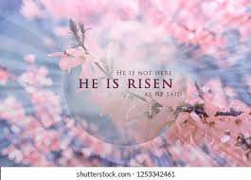

The liturgist is Heidi Duncanson.
The Greeters/Ushers this week are Joanne and Chris Shultz.
The flowers are given by Frank Manter in loving memory of his wife, Lynda.

Community Congregational Church (UCC)
Greenland, New Hampshire
Gathered in 1706
Pastor: Rev. Mark C. Brockmeier
Music Director: Sam Partyka
Ministers: All the members of this congregation
Church School suspended until further notice.
Church Office: 44 Post Rd. Open Wednesdays 12-7
PO Box 128 Greenland NH 03840
603-436-8336, greenlanducc@myfairpoint.net
Rev. Mark Brockmeier email: revbrock@bu.edu
Mobile: 603-818-2328

May 22, 2022 Easter 6C
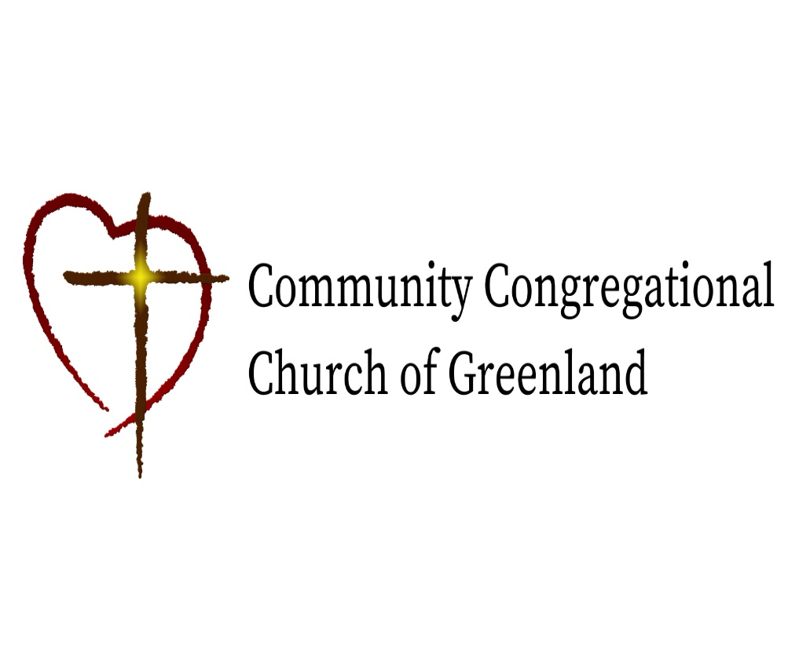

God calls us together to welcome all
and to serve God, each other, this community,
and the world
in the spirit of Christ’s love.
❖ All are welcome! 

