Welcome to Worship!

April 10, 2022 Palm Sunday C
Greetings and Announcements
Prelude "Trumpet Voluntary" Jeremiah Clarke

*Responsive Call to Worship based on psalm 118: 1-2, 19-25
Leader: O give thanks to the Lord, for he is good; his steadfast
love endures forever!
People: Let Israel say, “His steadfast love endures forever.”
Leader: Open to me the gates of righteousness, that I may enter
through them and give thanks to the Lord.
People: This is the gate of the Lord; the righteous shall enter
through it.
Leader: I thank you that you have answered me and have become
my salvation.
People: The stone that the builders rejected has become the
chief cornerstone.
Leader: This is the Lord’s doing; it is marvelous in our eyes.
People: This is the day that the Lord has made; let us rejoice
and be glad in it.
Leader: Save us, we beseech you, O Lord! O Lord, we beseech
you, give us success!

*Opening Hymn: "Lift Up Your Heads, O Mighty Gates" No. 176

*Unison Prayer of Invocation and Lord’s Prayer (debts)
Lord, just like with Holy Week and its emotional highs and lows for our faith, so our lives are filled with what swirls around us in our lives. Help us to live in the present moment, so that we might be most faithful to those we may serve right here, right now. Remind us of your eternal love and grace as when Jesus taught us to pray, saying....Our Father, who art in heaven, hallowed be thy name. Thy kingdom come, thy will be done on earth as it is in heaven. Give us this day our daily bread, and forgive us our debts, as we forgive our debtors. And lead us not into temptation, but deliver us from evil. For thine is the kingdom, and the power, and the glory forever. Amen

*Gloria Patri No. 734
Glory be to the Creator, and to the Christ: And to the Holy Ghost;
As it was in the beginning, is now and ever shall be: world without end. Amen.

congregational anthem "Ride On, Ride On" No. 268

Reading of the Word Luke 19: 28-40

Sermon Bewitched, Bothered, and Bewildered

Meditation Hymn: "This is the Day" No. 652

Prayers of the People

Call For The Offering

Offertory "What Wondrous Love is This" Carter

You may also mail your offering (P.O. Box 128, Greenland, NH 03840); Give on line by going to greenlanducc.org and click the "Donate" tab. Thank you!

*Doxology No. 34
Praise God, from whom all blessings flow:
Praise God, all creatures here below.
Praise God above, ye heavenly host;
Creator, Christ, and Holy Ghost. Amen
*Prayer of Dedication

*Closing Hymn: "All Glory, Laud, and Honor" No. 265

*Benediction

Postlude "Prelude in B-flat Major” Rachmaninoff

*Please stand if you are able.

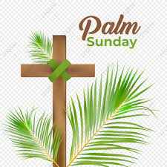

The liturgist is Bev Perriccio.
The greeters/ushers are Lee Pearl and Bev Perriccio.
The flowers are donated by Joanne Spradlin, celebrating family and loved ones.

Community Congregational Church (UCC)
Greenland, New Hampshire
Gathered in 1706
Pastor: Rev. Mark C. Brockmeier
Music Director: Sam Partyka
Ministers: All the members of this congregation
Church School suspended until further notice.
Church Office: 44 Post Rd. Open Wednesdays 12-7
PO Box 128 Greenland NH 03840
603-436-8336, greenlanducc@myfairpoint.net
Rev. Mark Brockmeier email: revbrock@bu.edu
Mobile: 603-818-2328

April 10, 2022 Palm Sunday C
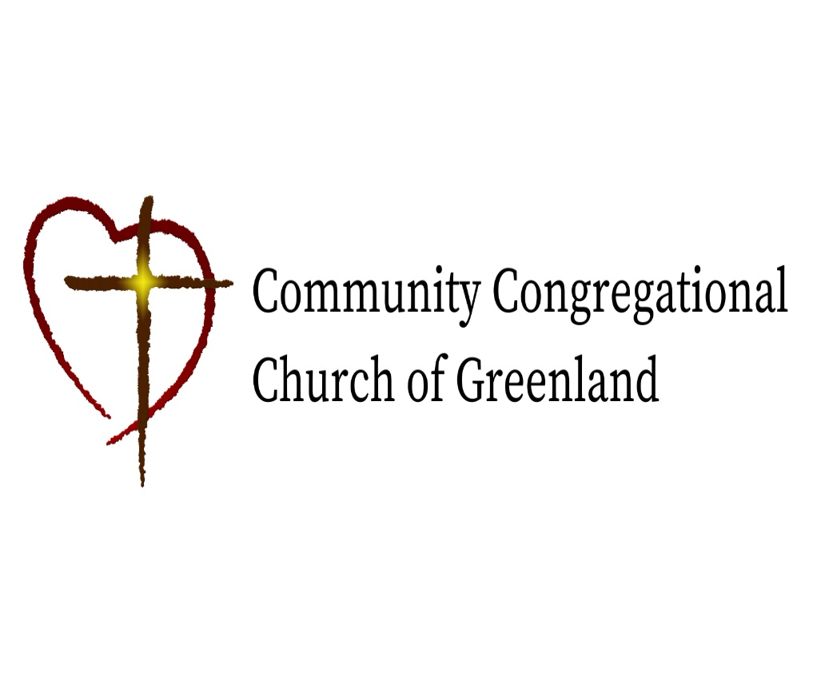

God calls us together to welcome all
and to serve God, each other, this community,
and the world
in the spirit of Christ’s love.
❖ All are welcome! 

