Welcome to Worship!

March 20, 2022 Lent 3C

Greetings and Announcements
Prelude Etude in C major Chopin

*Responsive Call to Worship based on psalm 63: 1-8
Leader: O God, you are my God, I seek you, my soul thirsts for
you; my flesh faints for you, as in a dry and weary land
where there is no water.
People: So I have looked upon you in the sanctuary,
beholding your power and glory.
Leader: Because your steadfast love is better than life, my lips
will praise you.
People: So I will bless you as long as I live; I will lift up my
hands and call on your name.
Leader: My soul is satisfied as with a rich feast, and my mouth
praises you with joyful lips
People: when I think of you on my bed, and meditate on you
in the watches of the night;
Leader: for you have been my help, and in the shadow of your
wings I sing for joy.
People: My soul clings to you; your right hand upholds me.

*Opening Hymn: "This is My Father's World" No. 21

*Unison Prayer of Invocation and Lord’s Prayer (debts)
Lord, we don't understand our world and at times seek to explain events away from your providence. Help us to know that even as we cannot comprehend why bad things happen to good people, you are with us, as when your Son taught us, praying...Our Father, who art in heaven, hallowed be thy name. Thy kingdom come, thy will be done on earth as it is in heaven. Give us this day our daily bread, and forgive us our debts, as we forgive our debtors. And lead us not into temptation, but deliver us from evil. For thine is the kingdom, and the power, and the glory forever. Amen

*Gloria Patri No. 734
Glory be to the Creator, and to the Christ: And to the Holy Ghost;
As it was in the beginning, is now and ever shall be: world without end. Amen.

choir anthem "Sing Praise to God"

Reading of the Word Isaiah 55: 1-13 and Luke 13: 1-9

Sermon Playing Favorites?

Meditation Hymn: "Come Away from Rush and Hurry"
No. 655

Prayers of the People
Call For The Offering
Offertory "He Leadeth Me" Sanborn

You may also mail your offering (P.O. Box 128, Greenland, NH 03840); Give on line by going to greenlanducc.org and click the "Donate" tab. Thank you!

*Doxology No. 34
Praise God, from whom all blessings flow:
Praise God, all creatures here below.
Praise God above, ye heavenly host;
Creator, Christ, and Holy Ghost. Amen

*Prayer of Dedication

*Closing Hymn: "Immortal, Invisible, God Only Wise" No. 48

*Benediction

Postlude "Let All Things Now Living" Larson

*Please stand if you are able.

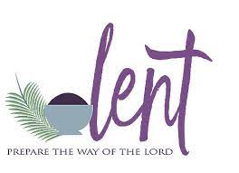

The liturgist is Bev Perriccio.
The Greeters/Ushers this week are Joanne Spradlin and Bev Perriccio.
The flowers are given in memory of Barbie Hazzard by Lee and Don Miller.

Community Congregational Church (UCC)
Greenland, New Hampshire
Gathered in 1706
Pastor: Rev. Mark C. Brockmeier
Music Director: Sam Partyka
Ministers: All the members of this congregation
Church School suspended until further notice.
Church Office: 44 Post Rd. Open Wednesdays 12-7
PO Box 128 Greenland NH 03840
603-436-8336, greenlanducc@myfairpoint.net
Rev. Mark Brockmeier email: revbrock@bu.edu
Mobile: 603-818-2328

March 20, 2022 Lent 3C
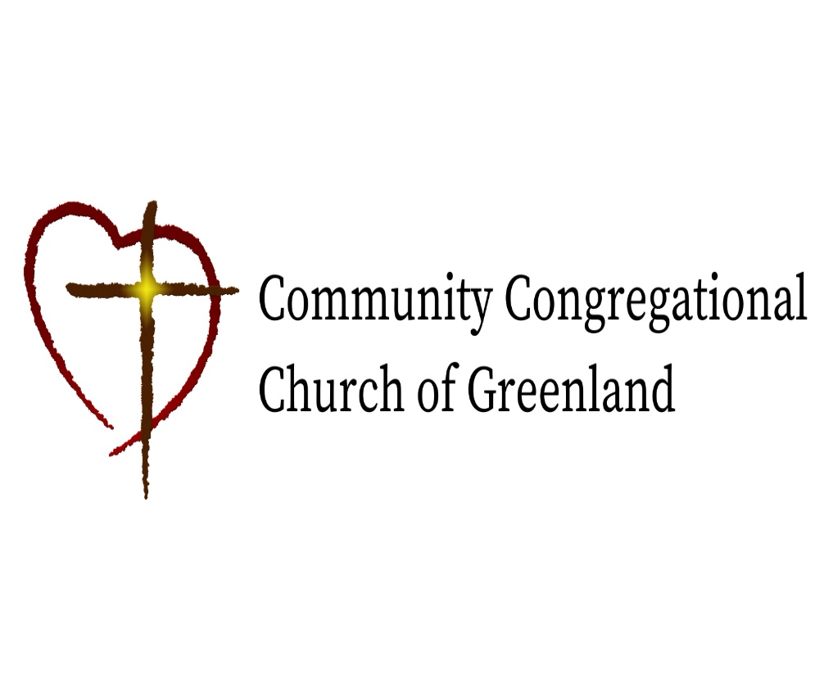

God calls us together to welcome all
and to serve God, each other, this community,
and the world
in the spirit of Christ’s love.
❖ All are welcome! 

