Welcome to Worship!

March 6, 2022 Lent 1C
COMMUNION SUNDAY
Greetings and Announcements
Prelude "Contemplation" Felix Mendelssohn

*Responsive Call to Worship based on psalm 91: 9-16
Leader: Because you have made the Lord your refuge, the Most
High your dwelling place,
People: no evil shall befall you, no scourge come near your
tent.
Leader: For he will command his angels concerning you to guard
you in all your ways.
People: On their hands they will bear you up, so that you will
not dash your foot against a stone.
Leader: You will tread on the lion and the adder, the young lion
and the serpent you will trample under foot.
People: Those who love me, I will deliver; I will protect those
who know my name.
Leader: When they call to me, I will answer them; I will be
with them in trouble, I will rescue them and honor
them.
People: With long life I will satisfy them, and show them my
salvation.

*Opening Hymn: "Lord, Who Throughout These Forty Days"
No. 252

*Unison Prayer of Invocation and Lord’s Prayer (debts)
Lord, we find ourselves tested during times when we feel alone in the world. Help us to know your presence in us, with us, and through us, as when your Son taught us to pray, saying...Our Father, who art in heaven, hallowed be thy name. Thy kingdom come, thy will be done on earth as it is in heaven. Give us this day our daily bread, and forgive us our debts, as we forgive our debtors. And lead us not into temptation, but deliver us from evil. For thine is the kingdom, and the power, and the glory forever. Amen

*Gloria Patri No. 734
Glory be to the Creator, and to the Christ: And to the Holy Ghost;
As it was in the beginning, is now and ever shall be: world without end. Amen.

choir anthem "Make Me a Channel of Your Peace"

Reading of the Word Luke 4: 1-13

Sermon Testing 1,2,3

Meditation Hymn: "Thy Word" No. 664

Holy Communion
Prayers of the People
Call For The Offering
Offertory "When I Survey the Wondrous Cross"

You may also mail your offering (P.O. Box 128, Greenland, NH 03840); Give on line by going to greenlanducc.org and click the "Donate" tab. Thank you!

*Doxology No. 34
Praise God, from whom all blessings flow:
Praise God, all creatures here below.
Praise God above, ye heavenly host;
Creator, Christ, and Holy Ghost. Amen

*Prayer of Dedication

*Closing Hymn: "Let The Whole Creation Cry" No. 6
*Benediction
Postlude "Fairest Lord Jesus" Mayo

*Please stand if you are able.

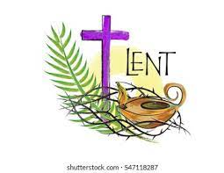

The liturgist is Bonnie Gardner.
The Greeters/Ushers this week are Bonnie Gardner and
Barbara Stone.
The flowers are given by Heidi Duncanson and Mark Weaver, in memory of Joann Duncanson and Lena Weaver, both born in March.

Community Congregational Church (UCC)
Greenland, New Hampshire
Gathered in 1706
Pastor: Rev. Mark C. Brockmeier
Music Director: Sam Partyka
Ministers: All the members of this congregation
Church School suspended until further notice.
Church Office: 44 Post Rd. Open Wednesdays 12-7
PO Box 128 Greenland NH 03840
603-436-8336, greenlanducc@myfairpoint.net
Rev. Mark Brockmeier email: revbrock@bu.edu
Mobile: 603-818-2328

March 6, 2022 Lent 1C
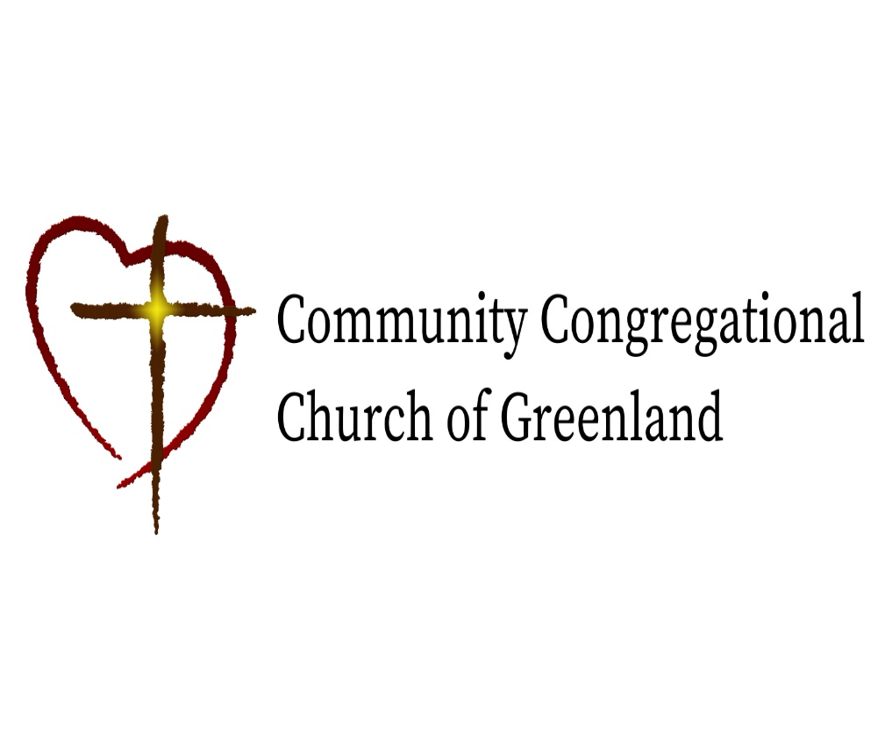

God calls us together to welcome all
and to serve God, each other, this community,
and the world
in the spirit of Christ’s love.
❖ All are welcome! 

