Welcome to Worship!

February 13, 2022 Epiphany 6c

Greetings and Announcements
Prelude "Consolation" Felix Mendelssohn
Responsive Call to Worship based on psalm 1: 1-6
Leader: Happy are those who do not follow the advice of the
wicked, or take the path that sinners tread, or sit in the
seat of scoffers;
People: but their delight is in the law of the Lord, and on his
law they meditate day and night.
Leader: They are like trees planted by streams of water, which
yield their fruit in its season, and their leaves do not
wither. In all that they do, they prosper.
People: The wicked are not so, but are like chaff that the
wind drives away.
Leader: Therefore the wicked will not stand in the judgment,
nor sinners in the congregation of the righteous;
People: for the Lord watches over the way of the righteous,
but the way of the wicked will perish.

Opening Hymn: "Two Thousand Years Since Bethlehem" No. 540

Unison Prayer of Invocation and Lord’s Prayer (debts)
Lord, we know that we are a people of blessing. Help us to extend those blessings to all who surround us, each day, just as your Son blessed your creation when he taught us to pray, saying.... Our Father, who art in heaven, hallowed be thy name. Thy kingdom come, thy will be done on earth as it is in heaven. Give us this day our daily bread, and forgive us our debts, as we forgive our debtors. And lead us not into temptation, but deliver us from evil. For thine is the kingdom, and the power, and the glory forever. Amen

Gloria Patri No. 734
Glory be to the Creator, and to the Christ: And to the Holy Ghost;
As it was in the beginning, is now and ever shall be: world without end. Amen.

The Message for All Ages

choir anthem "Softly and Tenderly, Jesus is Calling"

Reading of the Word Luke 6:17-26
Old Testament Jer 17: 5-10

Sermon “Windows on the World”

Meditation Hymn: "How Firm a Foundation" No. 411

Prayers of the People
Call For The Offering

Offertory "On Eagle's Wings" Wagner

You may also mail your offering (P.O. Box 128, Greenland, NH 03840); Give on line by going to greenlanducc.org and click the "Donate" tab. Thank you!

Doxology No. 34
Praise God, from whom all blessings flow:
Praise God, all creatures here below.
Praise God above, ye heavenly host;
Creator, Christ, and Holy Ghost. Amen

Prayer of Dedication

Closing Hymn: "O Christ, the Healer, We Have Come" No. 638

Benediction

Postlude "Amazing Grace" Schrader

The liturgist is Wendy Jones.
The Greeters/Ushers this week are Wendy and Turner Jones.
The flowers are given by Bonnie and Rod Gardner in honor of their anniversary.

Community Congregational Church (UCC)
Greenland, New Hampshire
Gathered in 1706
Pastor: Rev. Mark C. Brockmeier
Music Director: Sam Partyka
Ministers: All the members of this congregation
Church School suspended until further notice.
Church Office: 44 Post Rd. Open Wednesdays 12-7
PO Box 128 Greenland NH 03840
603-436-8336, greenlanducc@myfairpoint.net
Rev. Mark Brockmeier email: revbrock@bu.edu
Mobile: 603-818-2328

February 13, 2022 Epiphany 6C
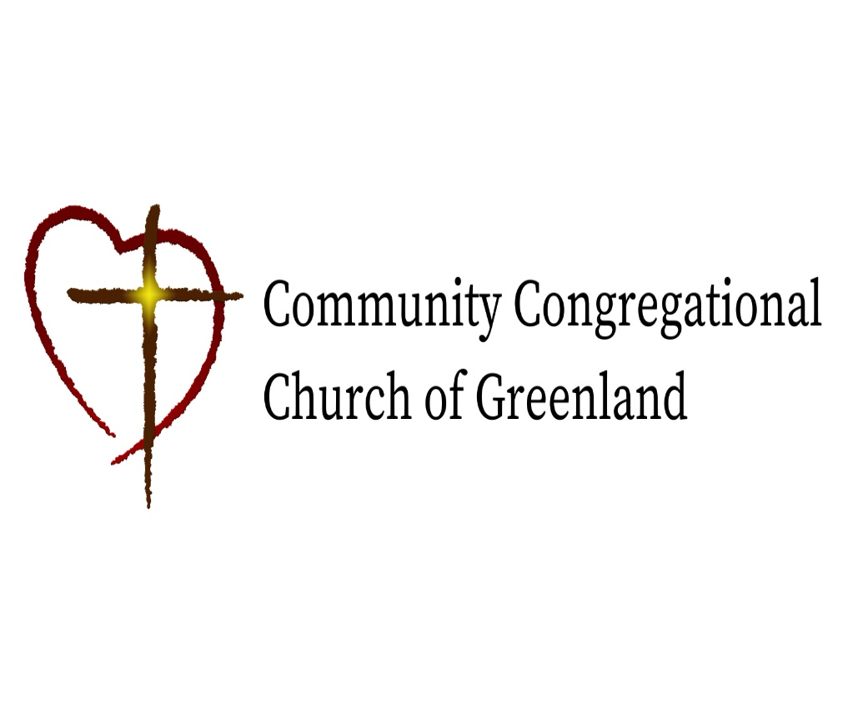

God calls us together to welcome all
and to serve God, each other, this community,
and the world
in the spirit of Christ’s love.
❖ All are welcome! 

