Welcome to Worship!

February 6, 2022 Epiphany 5c
COMMUNION SUNDAY
Greetings and Announcements
Prelude "O How Amiable Are Thy Dwellings" Rutter
Responsive Call to Worship based on psalm 138: 1, 4-8
Leader: I give you thanks, O Lord, with my whole heart;
before the gods I sing your praise.
People: All the kings of the earth shall praise you, O Lord,
for they have heard the words of your mouth.
Leader: They shall sing of the ways of the Lord, for great is the
glory of the Lord.
People: For though the Lord is high, he regards the lowly;
but the haughty he perceives from far away.
Leader: Though I walk in the midst of trouble, you preserve me
against the wrath of my enemies; you stretch out your
hand, and your right hand delivers me.
People: The Lord will fulfill his purpose for me; your
steadfast love, O Lord, endures forever. Do not
forsake the work of your hands.

Opening Hymn: "Take Up Your Cross" No. 351

Unison Prayer of Invocation and Lord’s Prayer (debts)
Lord, we are granted your grace each day, but focused more on ourselves and our fears than on you and hope for the world. Help us to trust that your way should be our way, as your Son did when he taught us to pray saying,....Our Father, who art in heaven, hallowed be thy name. Thy kingdom come, thy will be done on earth as it is in heaven. Give us this day our daily bread, and forgive us our debts, as we forgive our debtors. And lead us not into temptation, but deliver us from evil. For thine is the kingdom, and the power, and the glory forever. Amen
Gloria Patri No. 734
Glory be to the Creator, and to the Christ: And to the Holy Ghost;
As it was in the beginning, is now and ever shall be: world without end. Amen.

The Message for All Ages

choir anthem "Lord, You Have Come to the Lakeshore"

Reading of the Word Old Testament Isaiah 6:1-8
Gospel Luke 5: 1-11

Sermon “In the Deep End”

Meditation Hymn: "Jesus Calls Us O’er the Tumult" No. 345

Prayers of the People
HOLY COMMUNION
Call For The Offering

Offertory "Let Us Break Bread Together" Courtney

You may also mail your offering (P.O. Box 128, Greenland, NH 03840); Give on line by going to greenlanducc.org and click the "Donate" tab. Thank you!

Doxology No. 34
Praise God, from whom all blessings flow:
Praise God, all creatures here below.
Praise God above, ye heavenly host;
Creator, Christ, and Holy Ghost. Amen

Prayer of Dedication

Closing Hymn: "Grace Greater than our Sin" No. 353
Benediction

Postlude "All Creatures of our God and King" Partyka

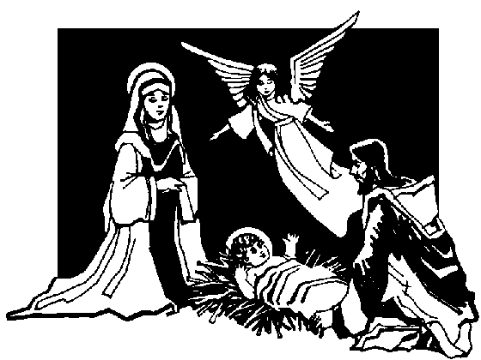

Many thanks to our guest musicians John Martin and
Alison Buchsbaum.

The liturgist is Dick Lates.
The Greeters/Ushers this week are BJ and Dick Lates.
The flowers are given in memory of S. Michael Wentworth by
Katie Wentworth.

Community Congregational Church (UCC)
Greenland, New Hampshire
Gathered in 1706
Pastor: Rev. Mark C. Brockmeier
Music Director: Sam Partyka
Ministers: All the members of this congregation
Church School suspended until further notice.
Church Office: 44 Post Rd. Open Wednesdays 12-7
PO Box 128 Greenland NH 03840
603-436-8336, greenlanducc@myfairpoint.net
Rev. Mark Brockmeier email: revbrock@bu.edu
Mobile: 603-818-2328

February 6, 2022 Epiphany 5C
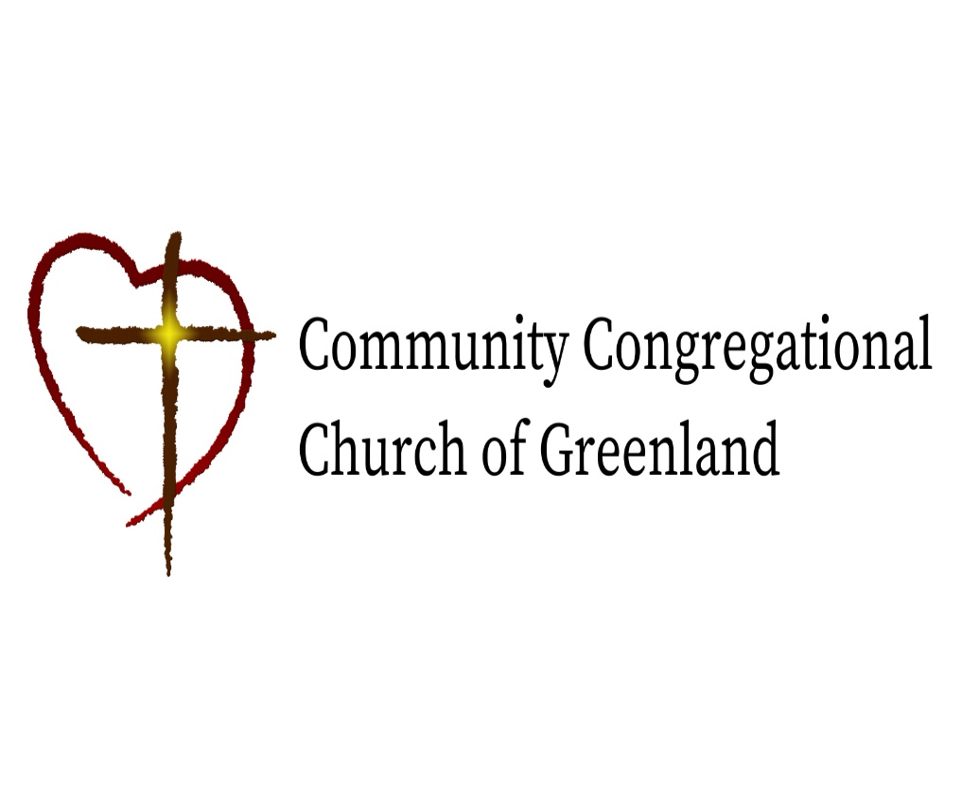

God calls us together to welcome all
and to serve God, each other, this community,
and the world
in the spirit of Christ’s love.
❖ All are welcome! 

