Welcome to Worship!

February 27, 2022 Transfiguration C

Greetings and Announcements
Prelude "Prelude in B♭ major" Chopin

*Responsive Call to Worship based on psalm 99: 1-5, 9
Leader: The Lord is king; let the peoples tremble! He sits
enthroned upon the cherubim; let the earth quake!
People: The Lord is great in Zion; he is exalted over all the
peoples.
Leader: Let them praise your great and awesome name. Holy
is he!
People: Mighty King, lover of justice, you have established
equity; you have executed justice and righteousness in
Jacob.
Leader: Extol the Lord our God; worship at his footstool. Holy is
he!
People: Extol the Lord our God, and worship at his holy
mountain; for the Lord our God is holy.

*Opening Hymn: "To God Be the Glory" No. 66

*Unison Prayer of Invocation and Lord’s Prayer (debts)
Lord, we wish to be better servants of your Word and the Way. Help us to better understand how we might change our hearts, as your Son taught us to pray, saying....Our Father, who art in heaven, hallowed be thy name. Thy kingdom come, thy will be done on earth as it is in heaven. Give us this day our daily bread, and forgive us our debts, as we forgive our debtors. And lead us not into temptation, but deliver us from evil. For thine is the kingdom, and the power, and the glory forever. Amen

*Gloria Patri No. 734
Glory be to the Creator, and to the Christ: And to the Holy Ghost;
As it was in the beginning, is now and ever shall be: world without end. Amen.

The Message for All Ages

choir anthem "O God, Our Help in Ages Past"

Reading of the Word Luke 9: 28-36

Sermon Show Me

Meditation Hymn: "Praise Him! Praise Him!" No. 95

Prayers of the People
Call For The Offering

Offertory "Be Thou My Vision" Partyka

You may also mail your offering (P.O. Box 128, Greenland, NH 03840); Give on line by going to greenlanducc.org and click the "Donate" tab. Thank you!

*Doxology No. 34
Praise God, from whom all blessings flow:
Praise God, all creatures here below.
Praise God above, ye heavenly host;
Creator, Christ, and Holy Ghost. Amen

*Prayer of Dedication

*Closing Hymn: "Now Thank We All Our God" No. 14

*Benediction

Postlude "Lead On, O King Eternal"

*Please stand if you are able.

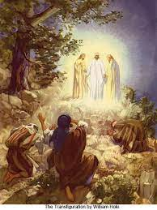

The liturgist is Katie Wentworth.
The Greeters/Ushers this week are Robin and John Weeks.
The flowers are given by Robin and John Weeks in memory of Robin’s parents.

Community Congregational Church (UCC)
Greenland, New Hampshire
Gathered in 1706
Pastor: Rev. Mark C. Brockmeier
Music Director: Sam Partyka
Ministers: All the members of this congregation
Church School suspended until further notice.
Church Office: 44 Post Rd. Open Wednesdays 12-7
PO Box 128 Greenland NH 03840
603-436-8336, greenlanducc@myfairpoint.net
Rev. Mark Brockmeier email: revbrock@bu.edu
Mobile: 603-818-2328

February 27, 2022 Transfiguration C
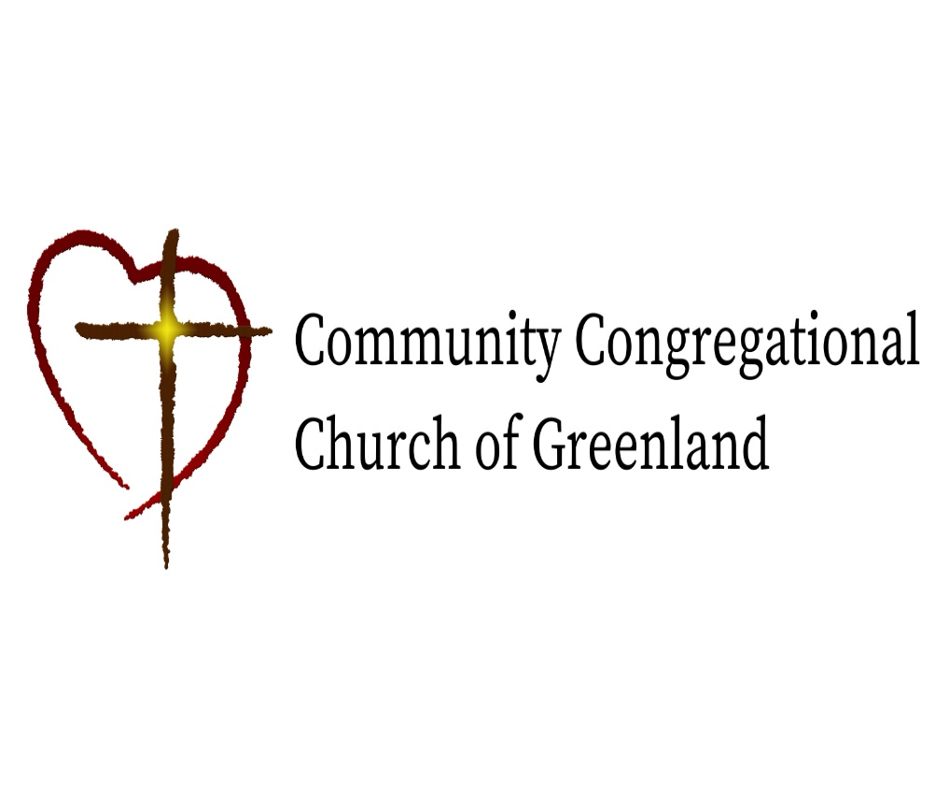

God calls us together to welcome all
and to serve God, each other, this community,
and the world
in the spirit of Christ’s love.
❖ All are welcome! 

