Welcome to Worship!

January 23, 2022 Epiphany 3c

Greetings and Announcements
Prelude "Prelude in D Major” J. S. Bach
Responsive Call to Worship based on psalm 19: 7-10, 13-14
Leader: The law of the Lord is perfect, reviving the soul;
the decrees of the Lord are sure, making wise the simple;
People: the precepts of the Lord are right, rejoicing the heart;
the commandment of the Lord is clear, enlightening
the eyes;
Leader: the fear of the Lord is pure, enduring forever; the
ordinances of the Lord are true and righteous altogether.
People: More to be desired are they than gold, even much fine
gold; sweeter also than honey, and drippings of the
honeycomb.
Leader: Keep back your servant also from the insolent; do not let
them have dominion over me. Then I shall be blameless,
and innocent of great transgression.
People: Let the words of my mouth and the meditation of my
Heart be acceptable to you, O Lord, my rock and my
redeemer.

Opening Hymn: "O For a Thousand Tongues to Sing” No. 96

Unison Prayer of Invocation and Lord’s Prayer (debts)
Lord, as we gather this week, give us the hearts to feel that your will is fulfilled right here, right now, this day through us. Help us to know your love through the prayer your Son taught us to pray, saying....Our Father, who art in heaven, hallowed be thy name. Thy kingdom come, thy will be done on earth as it is in heaven. Give us this day our daily bread, and forgive us our debts, as we forgive our debtors. And lead us not into temptation, but deliver us from evil. For thine is the kingdom, and the power, and the glory forever. Amen

Gloria Patri No. 734
Glory be to the Creator, and to the Christ: And to the Holy Ghost;
As it was in the beginning, is now and ever shall be: world without end. Amen.

The Message for All Ages

choir anthem " 'Tis So Sweet to Trust in Jesus"

Reading of the Word Luke 4: 14-21

Sermon “False and True Prophets”

Meditation Hymn: "Community of Christ” No. 615

Prayers of the People
Call For The Offering

Offertory "Beneath the Cross of Jesus" Rea

You may also mail your offering (P.O. Box 128, Greenland, NH 03840); Give on line by going to greenlanducc.org and click the "Donate" tab. Thank you!

Doxology No. 34
Praise God, from whom all blessings flow:
Praise God, all creatures here below.
Praise God above, ye heavenly host;
Creator, Christ, and Holy Ghost. Amen

Prayer of Dedication
Closing Hymn: “Lord Whose Love Through Humble Service” No. 575
Benediction
Postlude "Love Divine, All Loves Excelling" Sanborn

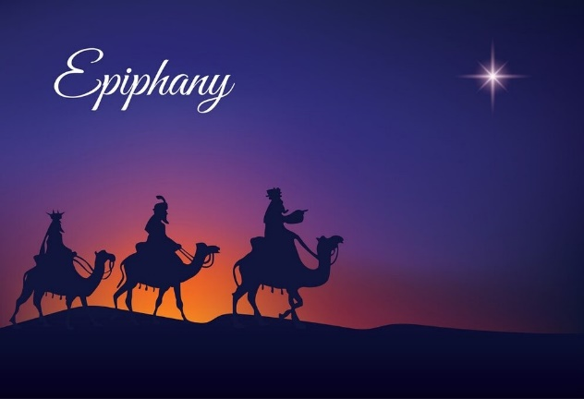

The Greeters/Ushers this week are Lee Pearl and Bev Perriccio.
Bev will also read the scripture lesson.
The flowers are given by Pastor Mark in honor of his Dad’s birthday. We send Ed Brockmeier a happy belated 90th birthday wish!

Community Congregational Church (UCC)
Greenland, New Hampshire
Gathered in 1706
Pastor: Rev. Mark C. Brockmeier
Music Director: Sam Partyka
Ministers: All the members of this congregation
Church School suspended until further notice.
Church Office: 44 Post Rd. Open Wednesdays 12-7
PO Box 128 Greenland NH 03840
603-436-8336, greenlanducc@myfairpoint.net
Rev. Mark Brockmeier email: revbrock@bu.edu
Mobile: 603-818-2328

January 23, 2022 Epiphany 3C
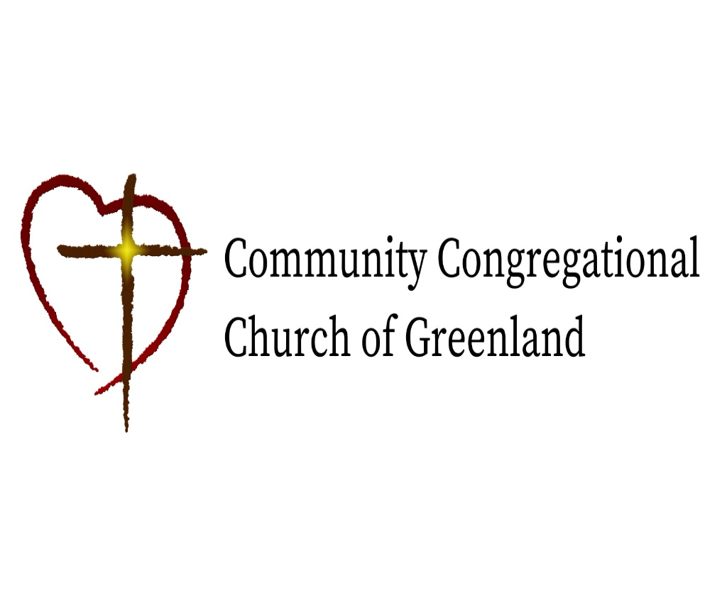

God calls us together to welcome all
and to serve God, each other, this community,
and the world
in the spirit of Christ’s love.
❖ All are welcome! 

