Welcome to Worship!

December 5, 2021 Advent 2C
COMMUNION SUNDAY
Greetings and Announcements
Prelude " * * * " R. Schumann
Advent Candle Lighting #175 V. 1, 3
We light the Advent candles against the winter night, to welcome our Lord Jesus who is the world’s True Light, to welcome our Lord Jesus who is the world’s True Light.
We light the second candle, and hear God’s holy Word, it tells us, cling to Jesus, prepare to meet your Lord, it tells us, cling to Jesus, prepare to meet your Lord!
Responsive Call to Worship Based on Luke 1: 68, 69, 76-79
Leader: Blessed be the Lord God of Israel, for he has looked
favorably on his people and redeemed them.
People: He has raised up a mighty savior for us in the house
of his servant David.
Leader: And you, child, will be called the prophet of the Most
High; for you will go before the Lord to prepare his
ways,
People: to give knowledge of salvation to his people
by the forgiveness of their sins.
Leader: By the tender mercy of our God, the dawn from on high
will break upon us,
People: to give light to those who sit in darkness and in the
shadow of death, to guide our feet into the way of
peace.

Opening Hymn: "On Jordan's Banks the Baptist's Cry" No. 156

Unison Prayer of Invocation and Lord’s Prayer (debts)
Lord, we are a fearful people, needing guidance when crisis comes. Help us remember and know your presence and guidance are ever-present, as you reminded us for all time as your Son taught us to pray, saying....Our Father, who art in heaven, hallowed be thy name. Thy kingdom come, thy will be done on earth as it is in heaven. Give us this day our daily bread, and forgive us our debts, as we forgive our debtors. And lead us not into temptation, but deliver us from evil. For thine is the kingdom, and the power, and the glory forever. Amen
Gloria Patri No. 734
Glory be to the Creator, and to the Christ: And to the Holy Ghost;
As it was in the beginning, is now and ever shall be: world without end. Amen.

The Message for All Ages

choir anthem "Lo, How a Rose E'er Blooming"

Reading of the Word Malachi 3: 1-4 and Luke 3: 1-6

Sermon Comforting Hope

Meditation Hymn: "Come, Thou Long-Expected Jesus" No. 153
Prayers of the People
Holy Communion
Call For The Offering
Offertory "What Child is This" Sanborn

You may also mail your offering (P.O. Box 128, Greenland, NH 03840); Give on line by going to greenlanducc.org and click the "Donate" tab. Thank you!
Doxology No. 34
Praise God, from whom all blessings flow:
Praise God, all creatures here below.
Praise God above, ye heavenly host;
Creator, Christ, and Holy Ghost. Amen
Prayer of Dedication
Closing Hymn: "Comfort Comfort Now My People” No. 155
Benediction
Postlude "Mary, Did You Know?" Schrader

The greeters/ushers are Robin and John Weeks.
The liturgist is Heidi Duncanson.

Community Congregational Church (UCC)
Greenland, New Hampshire
Gathered in 1706
Pastor: Rev. Mark C. Brockmeier
Music Director: Sam Partyka
Ministers: All the members of this congregation
Church School suspended until further notice.
Church Office: 44 Post Rd. Open Wednesdays 12-7
PO Box 128 Greenland NH 03840
603-436-8336, greenlanducc@myfairpoint.net
Rev. Mark Brockmeier email: revbrock@bu.edu
Mobile: 603-818-2328

December 5, 2021 Advent 2C
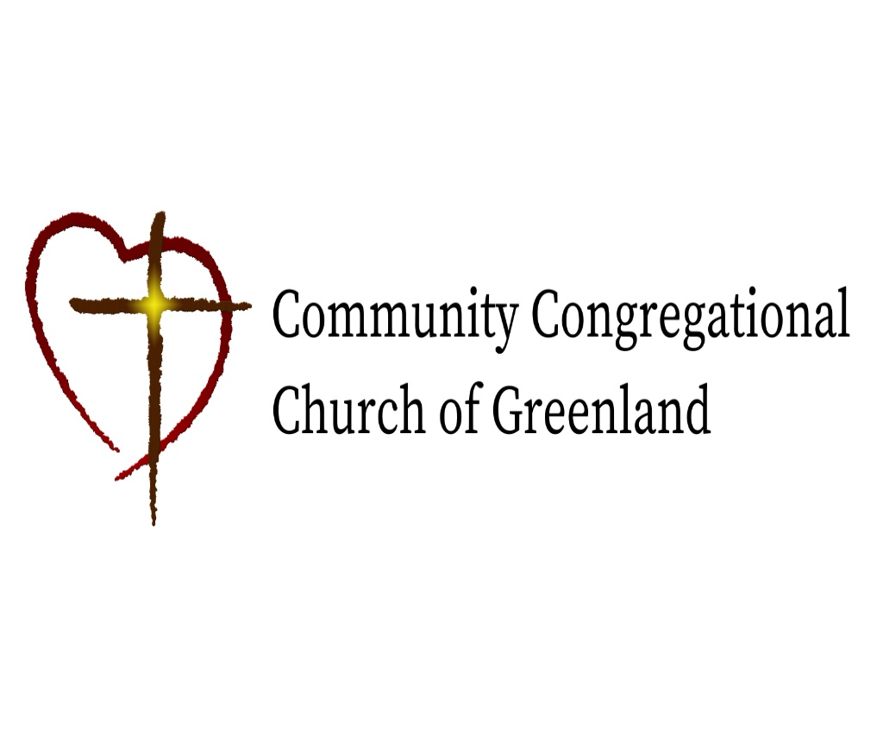

God calls us together to welcome all
and to serve God, each other, this community,
and the world
in the spirit of Christ’s love.
❖ All are welcome! 

