Welcome to Worship!

November 28, 2021 Advent 1c

Greetings and Announcements
Advent Candle Lighting #175 V. 1, 2 Karen & Fred Mason
We light the Advent candles against the winter night, to welcome our Lord Jesus who is the world’s True Light, to welcome our Lord Jesus who is the world’s True Light.
The first one will remind us that Christ will soon return. We light it in the darkness and watch it gleam and burn, We light it in the darkness and watch it gleam and burn.
Prelude "From Foreign Lands" R. Schumann

Responsive Call to Worship Based on Psalm 25: 1, 4-9
Leader: To you, O Lord, I lift up my soul.
People: Make me to know your ways, O Lord; teach me your
paths.
Leader: Lead me in your truth, and teach me, for you are the God
of my salvation; for you I wait all day long.
People: Be mindful of your mercy, O Lord, and of your
steadfast love, for they have been from of old.
Leader: Do not remember the sins of my youth or my
transgressions; according to your steadfast love
remember me, for your goodness’ sake, O Lord!
People: Good and upright is the Lord; therefore he instructs
sinners in the way.
Leader: He leads the humble in what is right, and teaches the
humble his way.

Opening Hymn: "Mine Eyes Have Seen" No. 730

Unison Prayer of Invocation and Lord’s Prayer (debts)
Lord, on this Sunday of love, prepare us to receive you in all your known and unknown ways, as we remember the prayer your Son taught us saying,.....Our Father, who art in heaven, hallowed be thy name. Thy kingdom come, thy will be done on earth as it is in heaven. Give us this day our daily bread, and forgive us our debts, as we forgive our debtors. And lead us not into temptation, but deliver us from evil. For thine is the kingdom, and the power, and the glory forever. Amen
Gloria Patri No. 734
Glory be to the Creator, and to the Christ: And to the Holy Ghost;
As it was in the beginning, is now and ever shall be: world without end. Amen.

The Message for All Ages

Reading of the Word Jer 33:14-16 and Luke 21: 25-36

Sermon

Meditation Hymn: "A Change to Keep I Have" No. 588

Prayers of the People

CALL FOR THE OFFERING

Offertory "Be Thou My Vision" Raney

You may also mail your offering (P.O. Box 128, Greenland, NH 03840); Give on line by going to greenlanducc.org and click the "Donate" tab. Thank you!
Doxology No. 34
Praise God, from whom all blessings flow:
Praise God, all creatures here below.
Praise God above, ye heavenly host;
Creator, Christ, and Holy Ghost. Amen

Prayer of Dedication

Closing Hymn: "Songs of Thankfulness & Praise” No. 243

Benediction

Postlude "Come, Thou Fount of Every Blessing" Mayo

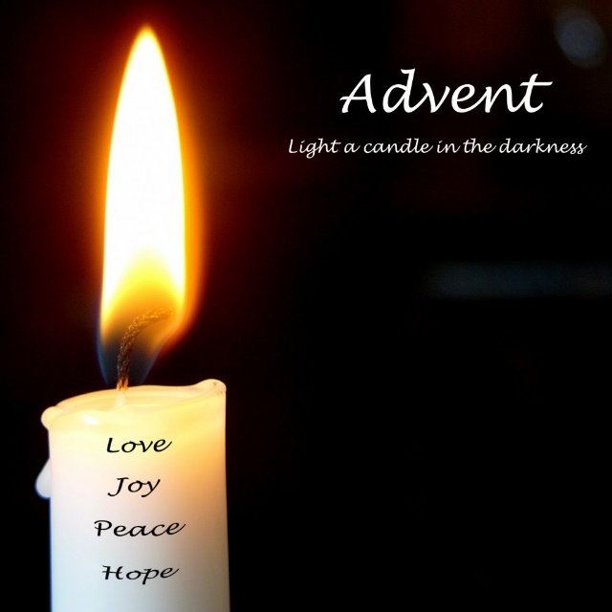

The flowers this Sunday are given by June Hurlbert, in memory of her husband, Paul. Our greeters/ushers are Linda and David Muchemore. The liturgist is Bonnie Gardner.

Community Congregational Church (UCC)
Greenland, New Hampshire
Gathered in 1706
Pastor: Rev. Mark C. Brockmeier
Music Director: Sam Partyka
Ministers: All the members of this congregation
Church School suspended until further notice.
Church Office: 44 Post Rd. Open Wednesdays 12-7
PO Box 128 Greenland NH 03840
603-436-8336, greenlanducc@myfairpoint.net
Rev. Mark Brockmeier email: revbrock@bu.edu
Mobile: 603-818-2328

November 28, 2021 Advent 1C
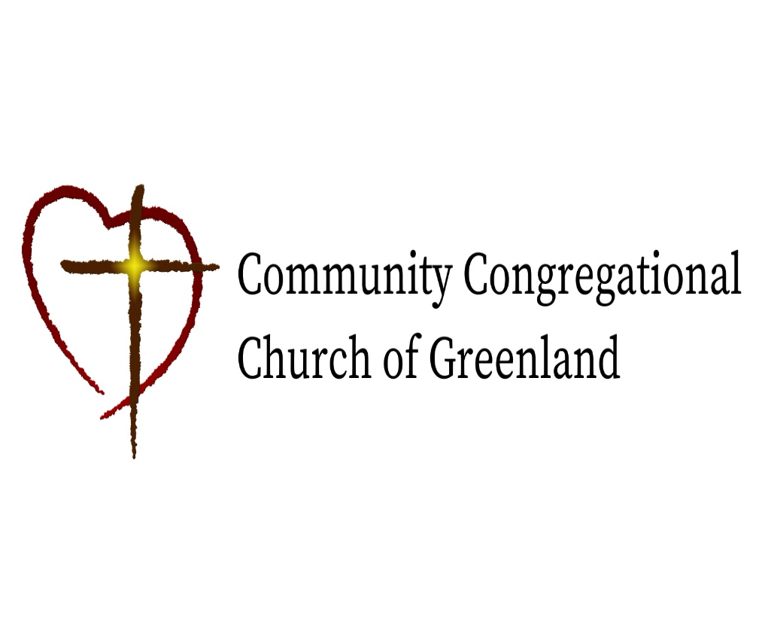

God calls us together to welcome all
and to serve God, each other, this community,
and the world
in the spirit of Christ’s love.
❖ All are welcome! 

